
Adapters: A Developer’s Guide
White Paper

Published: June 2004
For the latest information, please see http://www.microsoft.com/biztalk

Contents

Overview 5
BizTalk Architecture Overview 5
Messaging Engine Architecture 6
What is a BizTalk Adapter? 7
The ‘Elements’ of an Adapter 7
Adapter Registry File 8
Design-Time Component 10
Run-Time Components 10
Hosting Model 10
Isolated Adapters 11
Interfaces 12
IBaseMessage 12
Messaging Engine Interfaces 14
Adapter Interfaces 14
Receiver Interfaces 15
Transmitter Interfaces 16
Message Exchange Patterns 16
One-way (Asynchronous) 16
Request-Response Style Protocols (Sync-on-Async) 17
Solicit-Response Style Protocols 17
Request-Multi Response 17
Loop-Back 17
Initialization of Adapter 17
Adapter Creation 18
Receive Adapter Initialization 19
Transmit Adapter Initialization 20
Initialization of Isolated Adapters 21
Adapter Termination 22
Adapter Configuration 23
Receive and Send Handler Configuration 23
Receive Location Configuration 24
AddReceiveEndpoint 24
UpdateEndpointConfig 25
RemoveReceiveEndpoint 25
Send Port Configuration 25
Transport Proxy Batch 27
Batch Call Back 27
Batch Status codes 29
Batch Operations 30
Use Batches for Performance 30
Eagerly Releasing the Batch 31
Large Message Handling 31
Stream Based Processing 31
Stream Seekability 32
Receive Adapters 33
One way Submit 33
Request-Response 34
Request-Response Message Timeouts 35
Transmit Adapters 36
Blocking vs Non-Blocking Transmissions 36
Non-Batched Sends 37
Batched Sends 38
Handling Transmission Failures 39
Throwing an Exception from TransmitMessage 42
Solicit-Response 42
Dynamic Sends 45
Transactions 45
Transacted Receivers 46
Transacted Transmitters 46
Transacted Solicit-Response Adapters 48
Service Components and BYOT 48
Handling Failures 49
Suspending Messages 49
Database Off-Line 49
Writing to the Event Log / Tracing 49
Security and SSO 50
SSO Support for Receive Adapters 50
SSO Support for Send Adapters 51
Party Resolution 52
Breaking it all Apart and Putting it Back Together – SDK BaseAdapter 53
Performance Tips 53
Throttling In-Bound and Out-Bound 54
Debugging Tips 54
Adapter Testing 54
Function Testing 55
Stress Testing 55
Performance Testing 55
Adapter Certification Program 56

Overview
This document describes the best practices for developers to build scaleable and reliable Adapters for Microsoft® BizTalk® Server 2004. As well as describing the best practices this document details various aspects of the BizTalk Server internals that are pertinent to adapter development. While knowledge of the BizTalk Server internals is not required in order to develop an adapter, it is useful in order to understand how to fully utilize the engine and leverage it to its full potential. This document focuses on the Adapter Framework run-time API’s used to develop transport Adapters for the Messaging Engine. It is not the intention of this document to detail the Adapter Framework design-time since the product documentation and the SDK provides sufficient information to develop the design time component including UI localization.

BizTalk Server 2004 enables deep integration for custom transport Adapters both from the run-time and design time aspects. The intent of this document is to enable Adapter developers to take full advantage of the rich and flexible capabilities exposed to adapter developers in order to develop performance and scalable adapters.

BizTalk Architecture Overview
The figure below illustrates the high level architecture of the BizTalk run-time, the blue boxes indicate the areas of the run-time that are extensible whereby custom components maybe plugged into the run time. In addition to these, custom code may be executed in Orchestration schedules as well as in maps; however those areas as well as pipeline components are outside the scope of this paper.

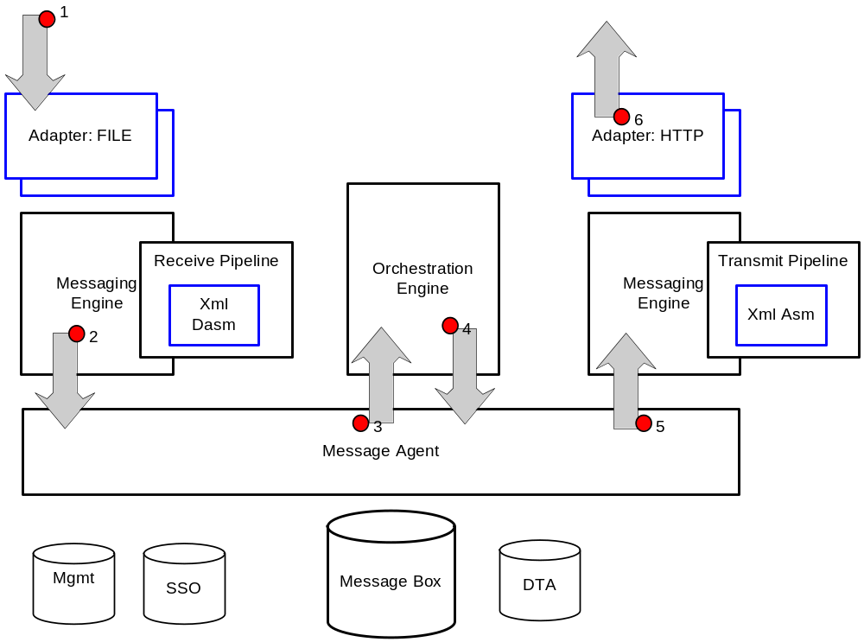

The diagram above illustrates the some of the routes through the BizTalk run-time that messages may take, in this diagram data is received from the ‘wire’ via an adapter, the ‘wire’ is an abstract notion of the source and destination of the data. In this scenario the ‘wire’ is the file system, the data is processed by the receive pipeline, and published to the Message Box via the Message Agent. The Message Agent / Message Box is in essence is a publish-subscribe engine. The published messages maybe routed to an Orchestration(s) or to a send port(s) hosted by the Messaging Engine or to both. On the outbound side, the message is processed by the transmit pipeline and then transmitted over the ‘wire’ which in this scenario is HTTP.

The process boundaries for the architecture maybe configured at design time, but essentially the three pieces of the architecture shown above, the Messaging Engine hosting receive adapters, the Orchestration Engine and the Messaging Engine hosting the transmit adapters may be executed in separate processes or the same process, or combinations of these. For more information on hosting see the section Hosting Model.

Messaging Engine Architecture
The diagram below illustrates the architecture of the Messaging Engine showing a scenario whereby a message is received by an Adapter and submitted into BizTalk Server.

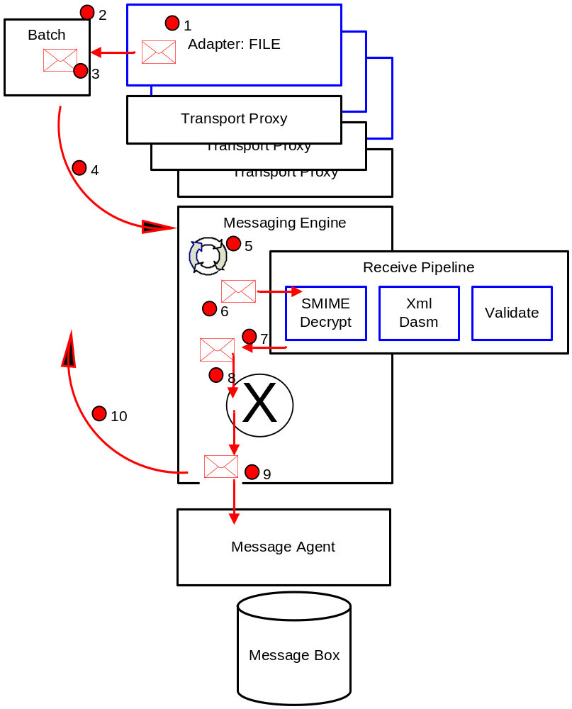

Each Adapter has its own instance of a Transport Proxy object which it uses to interact with the Messaging Engine. Adapters perform work against the Messaging Engine in batches, these will be described in detail later, but essentially a batch is a collection of ‘operations’ such as SubmitMessage, SuspendMessage, DeleteMessage amongst others, batches are processed atomically and asynchronously by the Messaging Engine.

The sequence of events for the scenario whereby an Adapter submits a message to the Messaging Engine is as follows:

- The Adapter creates a new message, wiring up the stream to the message
- The Adapter gets a new batch form the Messaging Engine via its Transport Proxy. It should be noted that each Adapter has it’s own Transport Proxy
- The Adapter adds a message to the batch to be submitted
- Done is called on the batch, causing it to be queued up on the Messaging Engines thread pool
- The Messaging Engine’s thread pool starts processing the new batch
- The message is processed in the receive pipeline
- Zero or more messages will be produced by the receive pipeline. Pipelines can consume messages providing they do not return any errors, receive pipelines can produce more than one message, typically this will be when the dissassembler component disassembles a single interchange into many messages. Typically the receive pipeline will normalize the message submitted into Xml.
- The message(s) produced by the pipeline may be processed in the mapper if mapping is configured
- The message(s) will be published to the Message Box.
- The Messaging Engine will callback the adapter to notify it of the outcome of that batch of work.

What is a BizTalk Adapter?
The primary responsibility of a BizTalk Adapter is to transfer data to and from the ‘wire’. The ‘wire’ is an abstract term used to describe the data source and destination, for example it could be FILE on disc, rows and columns in a SQL database, an HTTP endpoint or an SAP system. In general Adapters are not concerned with parsing, interpreting or changing the format of the data, though this is not disallowed.

Receive side Adapters are responsible for creating a new BizTalk message, attaching the network/data source stream to the message, typically this will be the body part of the message, adding any Meta data that is pertinent to the endpoint over which the data was received and then submitting that message into the Messaging Engine. The adapter will delete the data from the receive endpoint or send the appropriate acknowledge to the client indicating that the data has been accepted into BizTalk. Transmit side Adapters are responsible for sending the data in BizTalk messages to the specified endpoint.

In general, Adapters should be developed with performance in mind, the API’s exposed to Adapter developers allow adapters to take advantage of database batching which is typically the costly operations when considering run-time performance.

Further, Adapters can loosely be categorized as Transport Adapters and Application Adapters. Transport Adapters are typically concerned with moving the data to and from the wire in a performant manner flowing any transport protocol Meta data, examples of these would be HTTP, FILE, FTP, TCP. Application Adapters typically perform the role of integrating a back end system with BizTalk server, these should also be developed with performance in mind but here the problem domain is subtly different, Meta data from the application may also be flowed to and from BizTalk. Application Adapters will typically use a schema wizard at design time to dynamically ‘mine’ the schema from the application. Examples of Application Adapters are SQL, SAP, and PeopleSoft.

The ‘Elements’ of an Adapter
The figure below illustrates the three main elements of an adapter, the Adapters Registry file, the Adapters design-time component and the Adapters run-time component.

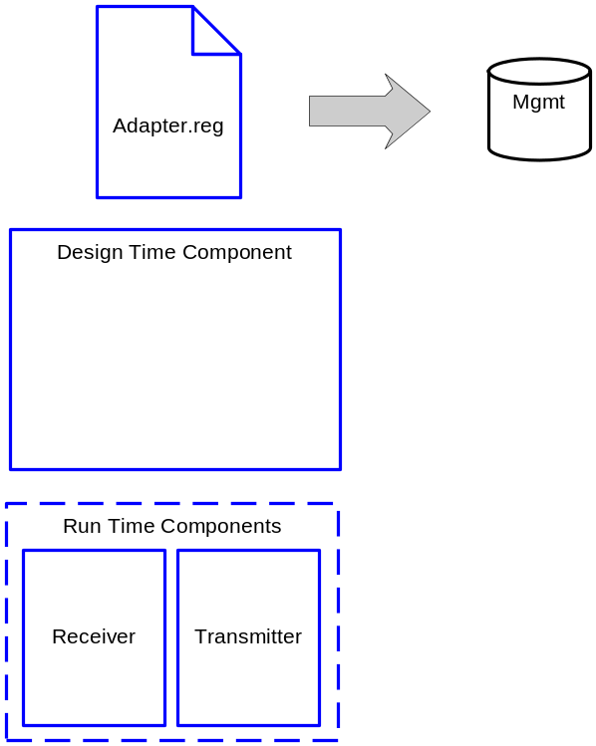

Adapter Registry File
The registry file contains Meta data associated with the adapter, this Meta data is added to the management data base at the time of creating an adapter in the Admin MMC. Rather than hand crafting this registry file it is recommended that the AdapterRegistryWizard.exe SDK utility is used to generate the registry file. The following information is contained in the registry file:

Name | Type | Description
TransportType | REG_SZ | Name of the Adapter
Constraints | REG_DWORD | The capabilities supported by the adapter, the product documentation details these, but in essence they describe the capabilities of the adapter, e.g. request-response, solicit-response, isolated adapter
OutboundProtocol_PageProv | REG_SZ | Property page for send handler configuration
InboundProtocol_PageProv | REG_SZ | Property page for receive handler configuration
ReceiveLocation_PageProv | REG_SZ | Property page for receive locations
TransmitLocation_PageProv | REG_SZ | Property page for send location
InboundEngineCLSID | REG_SZ | Class ID of the receiver, for COM adapters this will be the CLSID, for .Net adapters this will simply be a unique GUID
InboundTypeName | REG_SZ | The .Net type name of the class that implements receiving part of the adapter *
InboundAssemblyPath | REG_SZ | Path to the .Net assembly that implements receiving part of the adapter *
ReceiveHandlerPropertiesXML | REG_SZ | SSO registration of the Adapter Framework property page for receive handler **
ReceiveLocationPropertiesXML | REG_SZ | SSO registration of the Adapter Framework property page for receive location
OutboundEngineCLSID | REG_SZ | Class ID of the sender, for COM adapters this will be the CLSID, for .Net adapters this will simply be a unique GUID
OutboundTypeName | REG_SZ | The .Net type name of the class that implements sender part of the adapter
OutboundAssemblyPath | REG_SZ | Path to the .Net assembly that implements sender part of the adapter
AliasesXML | REG_SZ | URL prefixes used for dynamic port transport resolution
SendHandlerPropertiesXML | REG_SZ | SSO registration of the Adapter Framework property page for send location
SendLocationPropertiesXML | REG_SZ | SSO registration of the Adapter Framework property page for send location
PropertyNameSpace | REG_SZ | Namespace of the adapter properties. The properties will be stored on message context under this namespace ***
AdapterMgmtTypeName | REG_SZ | Type name of the class that provides UI for adapter property pages
AdapterMgmtAssemblyPath | REG_SZ | Path to the assembly that implments UI for adapter property pages

*
The *TypeName and *AssemblyPath fields are only applicable when using managed code

**
The adapters UI can be built using two approaches, developing property pages or using the BizTalk Adapter Framework which involves writing a small amount of code and defining an XSD schema that is later used to render the UI.

For the Adapter Framework the following Xml string maybe specified for ReceiveHandlerPropertiesXML, ReceiveLocationPropertiesXML, SendHandlerPropertiesXML and SendLocationPropertiesXML values:

<CustomProps>
<AdapterConfig vt="8" />
</CustomProps>

***
The PropertyNameSpace defines the namespace on the message context under which all adapter specific properties will be written, this is to prevent property name clashes between different adapters, then engine and other custom properties.

Design-Time Component
The UI for an adapter is implemented using the Adapter Framework which provides a very productive approach for UI development since the UI is rendered from an Xml schema, a small amount of code is required to be written.

Run-Time Components
Typically an adapter will consist of two public run-time components, the component that implements the receiver and the component that implements the transmitter, of course each of these may have many other internal components packaged up within the same assembly.

Implementation Tip: In general it is recommended that both the design-time and the run-time are developed using managed code.

Hosting Model
In general BizTalk adapters are hosted in the BizTalk service process, Btsntsvc.exe, this means that BizTalk manages the lifetime of the adapter, it will create the adapter, initialize it with its Transport Proxy, service the adapters requests and on service shutdown it will terminate the adapter. The BizTalk service maybe shutdown using the BizTalk Admin MMC or using the service control manager, in addition if connectivity to the BizTalk databases is lost the service will automatically re-cycle itself. BizTalk also delivers any configuration to the adapter at runtime including the handler configuration and the endpoint configuration. In addition, aspects of configuration such as service windows are handled by the Messaging Engine so that adapters do not need to worry about when an endpoint is outside of a service window.

The figure below illustrates the process hosting model for regular adapters, in this model the receive side adapters and send side adapters are all hosted in the BizTalk Service along with the Messaging Engine and the Orchestration Engine. The hosting model is flexible enough to allow for separation of receive, send and Orchestration hosts and combinations of these, in the diagram below the host is executing all three in the same process. Because of the rich hosting model, it is important when developing adapters to remember that the send and receive adapters may never be configured in the same host they may even be configured to run on different machines.

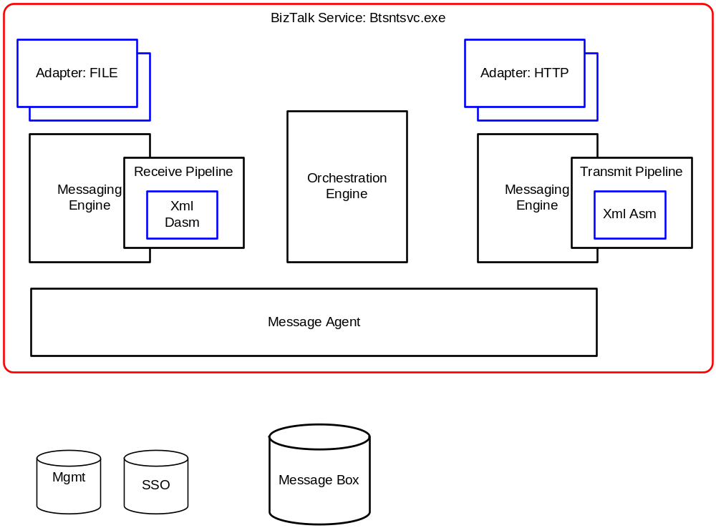

Isolated Adapters
There are scenarios when hosting receive adapters in the BizTalk process is not possible, for example the IIS process model is such that IIS manages the life time of ASP.NET applications and ISAPI Extensions, for Adapters where it is not possible for BizTalk to manage the lifetime of the adapter there is another hosting model, these are generally referred to as Isolated Receive Adapters, or simply Isolated Adapters since, there is no concept of an Isolated Send Adapter.

Since Isolated Adapters cannot be created, it is the responsibility of the Adapter to create its own Transport Proxy and register itself with the Transport Proxy.

The diagram below illustrate the architecture schematic, one thing worth noting here is that the architecture makes a conscious effort to eliminate any unnecessary inter-process communication. Since the Isolated Adapter and the BizTalk Messaging Engine stack are in the same process there is no inter-process communication when the adapter is calling the Messaging Engine, the only inter-process communication is between the Messaging Engine and the database, which is unavoidable.

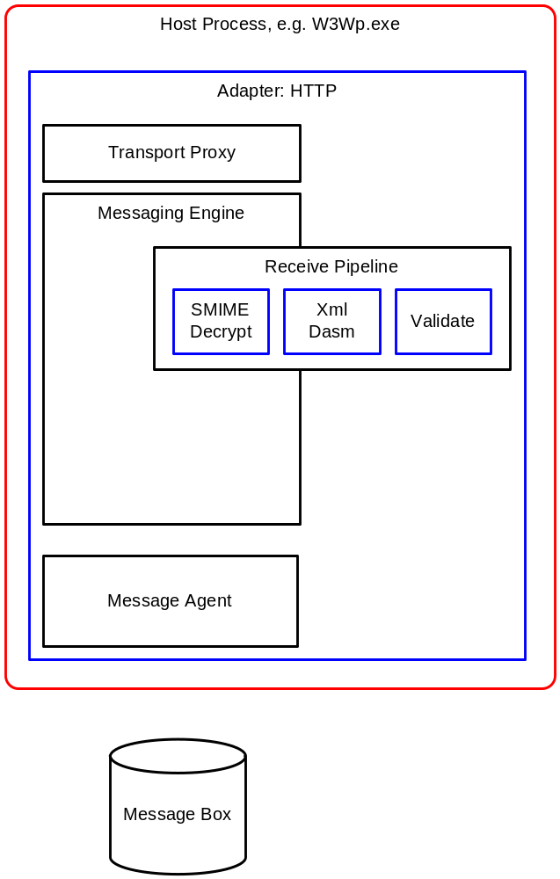

Interfaces

IBaseMessage
The interface on which BizTalk messages are implemented is the IBaseMessage interface. Each message has one or more message parts, IBaseMessagePart, each message part has a reference to it’s data, IStream. Each message has a message context, IBaseMessageContext. The following diagram illustrates the BizTalk message object model.

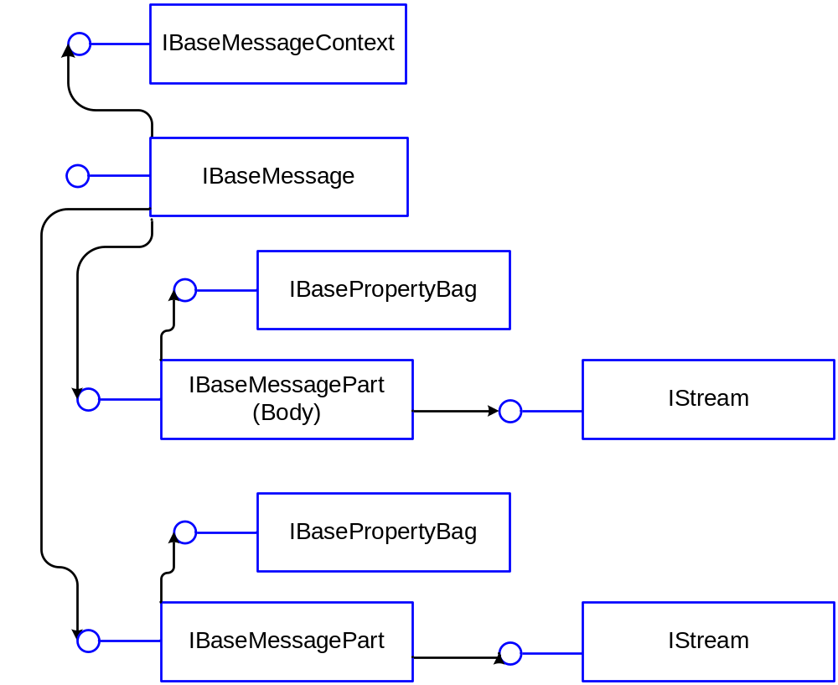

The message context is a dictionary which is keyed on a combination of the property name and the property namespace, this prevents collisions between similarly named properties from different sources, e.g. BizTalk system properties and custom adapter properties. The values for these properties are of type object in .Net, under the covers however these properties are VARIANT’s. In addition as can be seen form the diagram above, each part also has a part context which is also a dictionary, but the part context does not have the notion of a namespace. Part context is Meta data referring to the data for that part, for example the Charset property.

Properties maybe written and read from the message context, in addition they maybe promoted. Properties that are written are Meta data that flows with the message, down stream components or user code in Orchestration may read the properties and of course write new values to them. Properties should only be promoted if they are intended to be used for message routing, once a property has been matched to an existing subscription and therefore used to route a message, the property is demoted to prevent cyclic subscription matches, a demoted property remains on the message context as Meta data. Promoted properties may also be read in the same way as properties that are only written, in this respect they are also Meta data that flows with the message.

Implementation Tip: Message context properties will be loaded into memory at run-time, very large pieces of data should not be written to the message context as this could potentially break the BizTalk large message support. Objects maybe written to the message context providing they implement IPersistStream. Also, promoted properties are limited to 255 characters.

The message factory should always be used to create new messages, the following code snippet illustrates how to create a new BizTalk message.

using Microsoft.BizTalk.Message.Interop;

IBaseMessage CreateMessage( Stream s,
IBaseMessageFactory msgFactory )
{
IBaseMessage msg = null;

IBaseMessagePart part = msgFactory.CreateMessagePart();
part.Data = s;
msg = msgFactory.CreateMessage();
msg.AddPart("body", part, true);

return msg;
}

Messaging Engine Interfaces
The Messaging Engine has three public interfaces that adapters use, these are outlined in the table below:

Name | Description
IBTTransportProxy | Adapters always interact with the Messaging Engine via their own Transport Proxy. The Transport Proxy is used amongst other things to create batches, get the message factory, register isolated receivers with the engine.
IBTTransportBatch | The interface exposed by the Messaging Engines batch, work done against the engine is performed using a batch, batches are processed asynchronously by the Messaging Engine
IBTDTCCommitConfirm | Adapters using DTC transactions on batches must notify the engine of the outcome of the transaction using this interface

Adapter Interfaces
There are three interfaces that are mandatory to implement for all adapters and a further two that are optional.

Name | Mandatory | Description
IBaseComponent | Yes | Interface detailing the Name, Version and the Description of the Adapter
IBTTransport | Yes | Interface detailing the Transport Type and the ClassID of the Adapter
IBTBatchCallback | Yes | Call-back interface on which the adapter will be notified of the outcome of a batch of work that it has done against the engine
IPersistPropertyBag | No | Configuration interface on which handler configuration will be delivered to the Adapter. This interface is not required for Adapters that do not have handler configuration
IBTTransportControl | No | Used to initialize and terminate an Adapter, the Adapters Transport Proxy is passed on this interface. This interface is not required for isolated adapters

Receiver Interfaces
In addition to the standard Adapter interfaces, Receive Adapters need to also implement IBTTransportConfig. This is the interface on which receive location configuration will be delivered to the adapter, this is detailed later in this documents.

In additional, two-way Receive Adapters, which are usually referred to as Request-Response need to implement IBTTransmitter, the IBTBatchTransmitter interface is not supported for Request-Response adapters . The diagram below illustrates this:

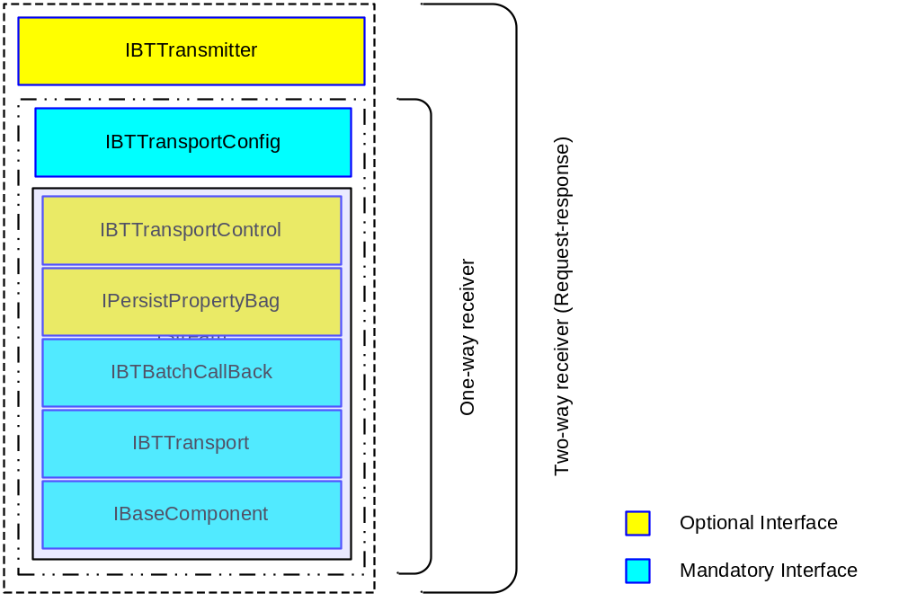

Transmitter Interfaces
Transmit Adapters need to either implement IBTTransmitter if they are non-batched or IBTBatchTransmitter if they are batched.

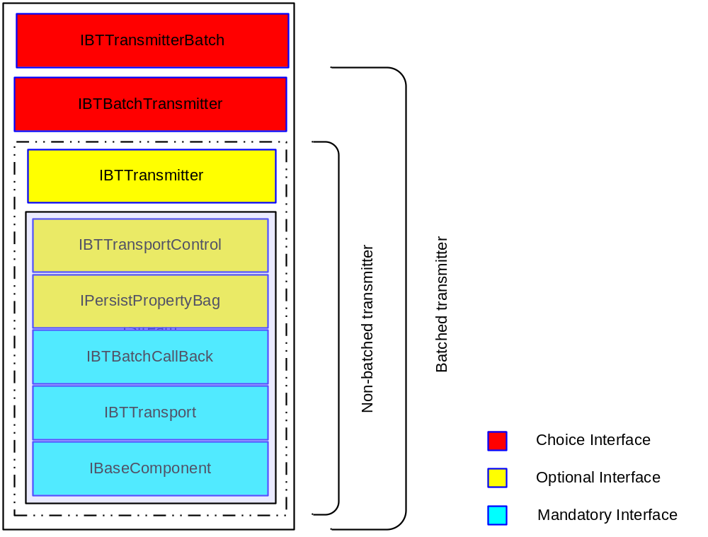

Message Exchange Patterns
The Adapter Framework supports a rich set of message exchange patterns that maybe utilized by Adapters to enable many powerful scenarios, these message exchange patterns may effectively be ‘stitched’ together using messaging and Orchestrations to enable powerful scenarios.

One-way (Asynchronous)
In this message exchange pattern, messages flow into BizTalk through an Adapter, the Messaging Engine publishes the message into the message box, the message could be routed to Orchestration which subsequently published the message back into the message box and finally the message is routed to an adapter to be sent out over the wire. The key concept here is that messages flow in one direction, a message is submitted into the engine, no response is expected. On the outbound side the message is transmitted over the wire, no response is expected. This is typically referred to as asynchronous messaging and is in many ways the basic building block used by the engine for all scenarios.

Request-Response Style Protocols (Sync-on-Async)
This scenario consists of receiving a request message, and then sending a response message. It is also referred to as synchronous-on-asynchronous, this is because the underlying BizTalk architecture is asynchronous for scalability reasons; however the architecture of the BizTalk engines enables exposing a synchronous message exchange pattern on top of these asynchronous exchanges, the engine handles the complex task of correlating the request and response messages together across a scale out architecture by stitching together a number of asynchronous message exchanges in order to expose a synchronous interface.

For example, a web page that checks inventory may make a SOAP call to a BizTalk SOAP receive adapter, BizTalk orchestrates a series of Web-Services aggregating the information and returning it as the SOAP response. To the client this appears to be a synchronous SOAP call but under the covers the engine knits together a number of asynchronous message exchanges.

Solicit-Response Style Protocols
This scenario is initiated by sending a message and then completed by receiving a message, it is referred to as solicit-response since the message sent is soliciting an endpoint for a response message. A scenario using this message exchange pattern may involve an orchestration making an outbound HTTP call (a solicit for a response) and waiting for the response.

Request-Multi Response
This scenario is very similar to the request-response scenario, but, in this scenario, multiple responses maybe returned for a given request, the number of responses is non-deterministic from the engines standpoint, the API’s allow a timeout value be specified whereby all responses receive within the timeout will be returned to the receive adapter.

Loop-Back
This scenario is very similar to the request-response scenario, the request message is published as usual, but in this scenario the engine will ensure the response message is routed back to the adapter. Since the request message is publish to the message box, the tracking infrastructure will ensure both the request and response messages are tracked.

An example of this would be a scenario whereby the client required a receipt for the message received that would be atomically returned to the adapter within the same batch containing the message that was published to the message box. The inbound message would be copied, one instance being returned to the client whilst the other would be processed in the normal manner. This specific scenario would also require a custom Xml Dissassembler to be written but, is another powerful scenario.

Initialization of Adapter
The following section describes how adapters are created and initialized. On service startup all the receive adapters that have one or more active receive locations configured for them are created. By default transmitters are lazily created in the same way as receivers, they are not created until the Messaging Engine de-queues the first message to be sent via that transmit adapter. The capability InitTransmitterOnServiceStart may be specified to direct the Messaging Engine to create the transmit adapter on service startup, rather than using the default lazy creation. The default lazy creation approach helps to reduce the amount of systems resources used when adapters are not configured on endpoints.

Adapter Creation
Adapters maybe developed using native COM components or managed code assemblies, though it is recommended that they are developed in managed code. For COM components the adapter will be created in the normal manner using CoCreateInstance(), for managed code adapters the .Net type needs to be specified in the configuration file whilst the assembly path is optional configuration, the following deployment options are possible:

.Net Type | Assembly Path | Assembly Deployment Method
Specified | Not specified | XCopy assembly to product directory or sub directory in the product directory with the same name as the assembly
Specified | Not specified | GAC assembly
Specified | Specified | XCopy assembly to directory specified

Trouble Shooting Tip: When developing managed code adapters, if creation fails, fuslogvw.exe is a useful tool to determine if there are references to assemblies that cannot be resolved, this is a common mistake.

The following diagram illustrates the logic for creating adapters depending on the configuration specified:
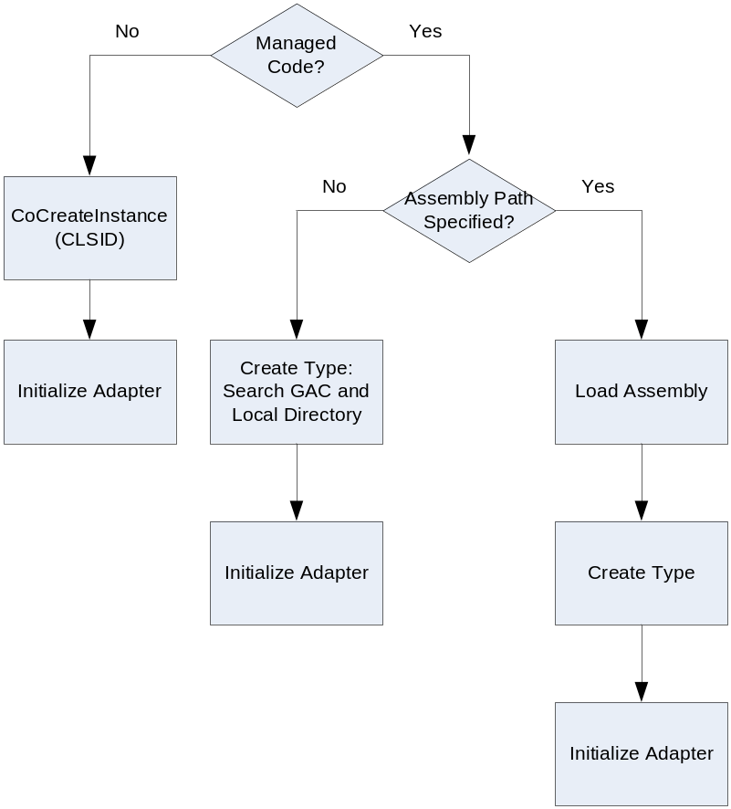

The following table gives an example of the configuration for a receive adapter and the three ways the runt-time assembly maybe configured for creation.

Deployment Option | InboundTypeName | InboundAssemblyPath
Specify assembly location | Microsoft.Samples.MyReceiveAdapter | C:\MyAdapter\MyAdapter.dll
Specify .Net type | Microsoft.Samples. MyReceiveAdapter,MyAdapter | N/A
GAC assembly | Microsoft.Samples. MyReceiveAdapter,MyAdapter | N/A

Receive Adapter Initialization
Once a Receive Adapter is created it is initialized, first the Messaging Engine will QueryInterface for the mandatory interface IBTTransportControl. Next it will QueryInterface for IPersistPropertyBag, this is an optional interface, if the adapter implements it the handler configuration will be passed to the adapter in the Load() method call. Next, the Engine will QueryInterface for IBTTransportControl, this is also a mandatory interface, the engine will then call Initialize() passing in the Adapters’ Transport Proxy. The final stage of initializing a receive adapter involves passing the endpoint configuration to the adapter, during this phase the engine will call IBTTransportControl.AddReceiveEndpoint() once for each active endpoint passing in the Uri for the endpoint, the adapter specific configuration for the endpoint and the BizTalk configuration for that endpoint.

The following diagram illustrates this sequence of API calls, the interfaces in blue are implemented by the adapter.
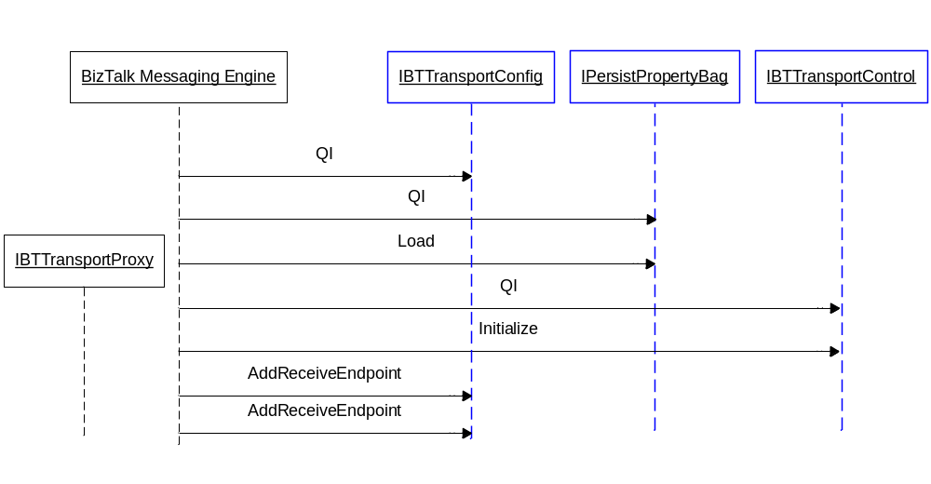

Implementation Tip: In general adapters should not block the engine in calls such as IBTTransportControl.Initialize(),IPersistPropertyBag.Load() and IBTTransportControl.AddReceiveEndpoint(), performing excessive processing in these calls will have an impact on service start up time.

Transmit Adapter Initialization
When the engine initializes transmit adapters if will first QueryInterface for IPersistPropertyBag, which is an optional interface, if the adapter implements it the handler configuration will be passed to the adapter in the Load() method call. Next, the Engine will QueryInterface for IBTTransportControl, this is a mandatory interface, the engine will then call Initialize() passing in the Adapters Transport Proxy. The Engine will then QueryInterface for IBTTransmitter, if this interface is discovered then the adapter will be treated as a batch unaware transmitter, if this interface is not discovered the Engine will QueryInterface for IBTBatchTransmitter, discovery of which will indicate that the adapter is a batch aware transmitter. If neither of these interface are discovered an error condition will result causing the initialization to fail as will the failure to discover any other mandatory interfaces.

The following diagram illustrates this sequence of API calls; the interfaces in blue are implemented by the adapter.

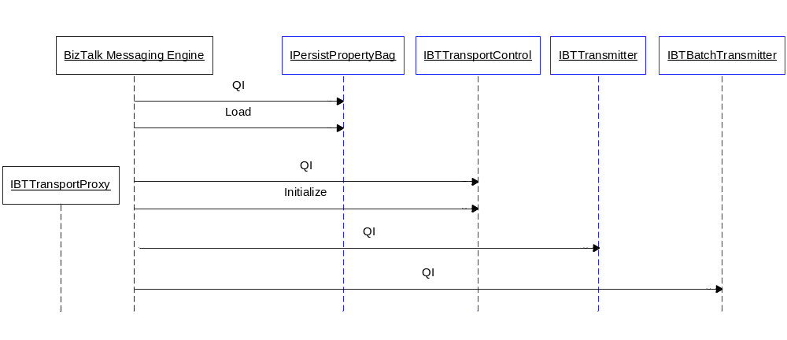

Initialization of Isolated Adapters
As discussed previously Isolated Adapters are not created by BizTalk, instead they are hosted by another process. It is then the responsibility of the Adapter to create the Transport Proxy, QueryInterface for IBTTransportProxy, and then call IBTTransportProxy.RegisterIsolatedReceiver() to register with the Messaging Engine.

Registration requires that the adapter passes one of it’s configured and enabled receive locations, the adapters host process must be running with the process credentials for that Isolated Host, the account under which the process is executing must be a member of the “BizTalk Isolated Host Users” group, it should be noted that simply using impersonation here will not be sufficient. In addition the Adapter will be queried to ensure it has the correct ClassID and is running on the machine that was configured for that host instance. Once the adapter has successfully registered with its Transport Proxy, its configuration will be pushed to it in the usual manner.

The following diagram illustrates this sequence of API calls; the interfaces in blue are implemented by the adapter.

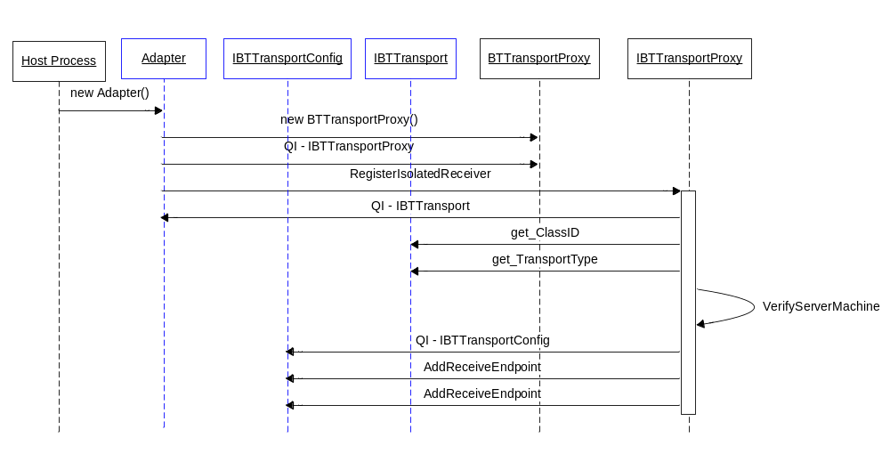

The following code snippet illustrates the registration API calls.

using Microsoft.BizTalk.TransportProxy.Interop;
using Microsoft.BizTalk.Component.Interop;
using Microsoft.BizTalk.Message.Interop;

public class MyAdapter : IBTTransport,
IBTTransportConfig,
IBTTransportControl,
IBaseComponent
{
...
private IBTTransportProxy transportProxy;

public void Register(string uri)
{
// Create the Transport Proxy...
this.transportProxy =
(IBTTransportProxy)new BTTransportProxy();

// Register on of the adapters uri’s with the TP
this.transportProxy.RegisterIsolatedReceiver(
uri,
(IBTTransportConfig)this );
}
}

Implementation Tip: It is recommended that the adapter keeps a count of the work in-flight, the adapter should block in Terminate() until the in-flight count has reached zero. For example on the receive side this work will include any outstanding requests that have not been published to BizTalk. It should be noted that response messages will typically not be delivered to a receive adapter once Terminate() has been called.

For send adapters, messages that are in-flight should be handled appropriately. This means any message that was successfully delivered should be deleted from the ApplicationQ to prevent messages from being double sent.

In general, once Terminate() is called the Messaging Engine will not accept requests to publish new messages with the exception of response messages for solicit-response pairs.

Adapter Termination
When the Messaging Engine is shutting down it will call IBTTransportControl.Terminate() on each adapter. Once this method returns the adapter will be destroyed, for managed adapters this is less deterministic due to the .Net garbage collection, regardless the adapter should block in Terminate() until it is ready to be destroyed. Any cleanup work should be done in Terminate() the adapter should block until this work has been completed.

Isolated receive adapters will not have Terminate() called on them since they are not hosted in the BizTalk service. Instead, they should call IBTTransportProxy.TerminateIsolatedReceiver() to notify the Messaging Engine that they are about to shutdown.

Adapter Configuration
Adapter configuration is stored in the SSO database by the design-time. At run-time the Messaging Engine retrieves the configuration for the Adapter and delivers it to the Adapter. There are four types of configuration that are delivered to adapters, these are:
- Receive handler configuration
- Receive location (endpoint) configuration
- Send handler configuration
- Send location (endpoint) configuration

Receive and Send Handler Configuration
As previously mentioned the handler configuration is delivered to the adapter on it’s implementation of IPersistPropertyBag.Load() which is an optional interface. The handler configuration is delivered once only, the adapter is not updated if the handler configuration is changed after the BizTalk Service has started. In general, the common model is for the adapter to treat the handler configuration as the default configuration; endpoint configuration overrides the handler configuration on a per endpoint basis.

The following code snippet demonstrates parsing the configuration, the adapters’ configuration will be in the property passed in to the Load call in the string property “AdapterConfig”, the property value will contain an Xml document representing the adapters configuration. The adapter needs to load this configuration into a DOM or an Xml Reader so that it can XPath to retrieve the individual properties.

public class MyAdapter : IBTTransport,
IBTTransportConfig,
IBTTransportControl,
IPersistPropertyBag,
IBaseComponent
{
...
// Handler configuration properties...
private int defaultBatchSize = 0;
private string defaultHeader;

// IPersistPropertyBag.Load() implementation...
public void Load(IPropertyBag pb, int pErrorLog)
{
// The adapter configuration is in the property
// “AdapterConfig” in the form of an Xml blob...
object obj = null;
pb.Read("AdapterConfig", out obj, 0);

// Create a DOM and load the Xml blob...
XmlDocument dom = new XmlDocument();
string adapterConfig = (string)obj;
dom.LoadXml(adapterConfig);

// XPath the individual properties...
XmlNode node =
document.SelectSingleNode(“/Config/batchSize”);
defaultBatchSize = int.Parse(node.InnerText);

node = document.SelectSingleNode(“/Config/header”);
defaultHeader = node.InnerText;
}
}

Receive Location Configuration
Receive location configuration is delivered to an adapter on it’s implementation of IBTTransportConfig, this interface has three methods AddReceiveEndpoint, UpdateEndpointConfig and RemoveReceiveEndpoint. The Messaging Engine will notify the adapter of which endpoints it needs to listen on / receive messages on, when the configuration for an endpoint is changed the adapter will be notified of the change for that endpoint. Similarly, the adapter does not need to worry about service windows, endpoints will be added and removed as service windows become active or inactive.

Trouble Shooting Tip: Adapter configuration is cached by the Messaging Engine for performance reasons; the engine will only look for changes in configuration every “cache refresh interval”. For this reason, there is a delta between changing the endpoints configuration and the adapter being notified of this change, in general this delta is less than the cache refresh interval, but when the server is under load this delta can be slightly longer. The cache refresh interval is configured in the Admin MMC at the group level.

AddReceiveEndpoint
When an Adapter needs to begin listening on an endpoint the engine will call IBTTransportConfig.AddReceiveEndpoint() passing in the receive locations uri, a property bag containing the adapters configuration for that endpoint and a second property bag containing BizTalk specific configuration for that endpoint. The uri passed needs to be written to the message context as the BizTalk system property InboundTransportLocation by the adapter.

Reading the receive location properties form the adapters property bag is no different from reading the handler configuration as detailed above. The BizTalk configuration passed into the adapter contains a single property, TwoWayReceivePort, this indicates whether the port is one way or two way. The following code snippet illustrates how to evaluate if the receive port is one-way or two-way from the BizTalk property bag:

public void AddReceiveEndpoint(
string url,
IPropertyBag adapterConfig,
IPropertyBag bizTalkConfig )
{
...

// The property "TwoWayReceivePort" in the BizTalk Config
// property bag indicates whether the port is one or two
// way...

// Add receive location to config cache (not shown here)

object obj = null;
bizTalkConfig.Read("TwoWayReceivePort", out obj, 0);

if ( null != obj )
this.twoWay = (bool)obj;
}

UpdateEndpointConfig
When the configuration of a receive location that is already active is changed, the engine will notify the adapter that it needs to use different configuration via the API UpdateEndpointConfig(). All of the configuration will be delivered to the adapter, including the BizTalk specific configuration.

RemoveReceiveEndpoint
When a receive location is no longer active, the adapter will be notified via RemoveReceiveEndpoint(), once the adapter returns from RemoveReceiveEndpoint() it will no longer be allowed to submit messages into the engine using that uri.

Send Port Configuration
The Messaging Engine writes the configuration for the send port on to the message context in the adapter’s namespace before delivering the message to the adapter. It is the adapters’ responsibility to read and validate that configuration which it will subsequently use to control the transmission of the message. For transmit adapters that support batched sends, messages destined for different send ports may be in the same batch, so the adapter will need to handle these ‘mixed’ batches.

The following code snippet illustrates firstly how to read the OutboundTransportLocation which is the uri for the send port, then how to read the Xml blob containing the adapters configuration and subsequently read the individual properties.

...
private static readonly PropertyBase UriProperty =
new BTS.OutboundTransportLocation();

private string propertyNamespace =
"http://schemas.mySchemas.com/MyAdapter/myadapter-properties";
private string uri;
private string headers;
private int timeOut = 1000;

private void ReadSendPortConfig(IBaseMessage msg)
{
// Read the OutboundTransportLocation,
// i.e. the send port uri....
uri = (string)msg.Context.Read(
UriProperty.Name.Name, UriProperty.Name.Namespace);

// Read the adapters configuration Xml blob from
// the message...
XmlDocument locationConfigDom = null;
object obj = msg.Context.Read(
"AdapterConfig", this.propertyNamespace);

// If this is a dynamic send there will not be
// any configuration...
if ( null != obj )
{
locationConfigDom = new XmlDocument();
locationConfigDom.LoadXml((string)obj);

this.headers = Extract(
locationConfigDom, "/Config/headers", true);

this.timeOut = ExtractInt32(
locationConfigDom, "/Config/timeOut", true);
}
}

// Helper method to XPath string properties...
private static string Extract(
XmlDocument document, string path, bool required)
{
XmlNode node = document.SelectSingleNode(path);
if (!required && null == node)
return String.Empty;
if (null == node)
throw new ApplicationException(string.Format(
"No property was found at {0}", path));
return node.InnerText;
}

// Helper method to XPath int32 properties...
private static int ExtractInt32(
XmlDocument document, string path, bool required)
{
string s = Extract(document, path, required);
return int.Parse(s);
}

Implementation Tip: Adapters should in general use the OutboundTransportLocation message context property to determine the address which to send the message to. By doing this the adapter will be able to handle transmissions to both static and dynamic sends consistently and also, the modification of address in production binding files will be simplified.

Transport Proxy Batch
Adapters do work against the engine using a Transport Proxy batch. The type of work to be performed in the batch is categorized as different operations; these operations are defined by the enumeration BatchOperationType. Batches are processed asynchronously, meaning that when an Adapter call’s Done() on a batch, the batch is posted to the engines thread pool, the calling thread will then return to the Adapter, and the batch will be processed in the engines thread pool, after processing has completed the Adapter will be notified of the batch outcome later via a callback.

Batch Call Back
Since batches are processed asynchronously, the Adapter needs a mechanism to tie a callback to some state in the Adapter so that the Adapter can perform the necessary cleanup actions. The callback semantics are flexible such that Adapters can use one or a combination of three approaches, these are:

- All callbacks made on the same object instance that implements IBTBatchCallBack, the cookie passed into the engine when requesting a new batch is used to correlate the callback to the state in the Adapters
- Having a different callback object for each batch that implements IBTBatchCallBack, each object holds all the state necessary
- A combination of #1 and #2

The Adapter is called back on it’s implementation of IBTBatchCallBack.BatchComplete(). The overall status of the batch is indicated by the first parameter, status. This is an HRESULT, since batches are atomic, if this value is greater than or equal to zero, then the batch was successful in the sense that the engine has ownership of the data and the Adapter is free to delete that data from the ‘wire’. A negative status indicates that the batch failed, this means that none of the operations in the batch were successful and the Adapter is responsible for handling the failure.

If the batch failed then the Adapter may need to know which item in which operation failed. For example, if an the Adapter was reading twenty files from disc and submitting them into BizTalk using a single batch, if the tenth file was corrupted, the Adapter would need to suspend that one file and resubmit the remaining nineteen. This information is available to the adapter in the second and third parameters, opCount of type short and operationStatus which is of type BTBatchOperationStatus[]. The operation count indicates how many types of operations were in the batch (the size of the array BTBatchOperationStatus array). Each element in the operation status array corresponds to a given operation type, using the BTBatchOperationStatus the Adapter can determine which item in a given operation failed by looking at BTBatchOperationStatus.MessageStatus[]. In this particular scenario, the adapter would then need to create a new batch containing nineteen submits and one suspend. The MessageStatus array is again an array of HRESULT’s meaning that a failure code will be negative.

The following code snippet illustrates how an Adapter would requests a new batch from the engine via it’s Transport Proxy, and submits a single message into the engine, this snippet uses the cookie approach:

using Microsoft.BizTalk.TransportProxy.Interop;
using Microsoft.BizTalk.Message.Interop;

public class MyAdapter :
IBTTransport,
IBTTransportConfig,
IBTTransportControl,
IPersistPropertyBag,
IBaseComponent,
IBTBatchCallBack
{
private IBTTransportProxy _tp;

public void BatchComplete(
Int32 status,
Int16 opCount,
BTBatchOperationStatus[] operationStatus,
System.Object callbackCookie)
{
// Use cookie to correlate callback with work done,
// in this example the batch is to submit a single
// file the name of which will be in the
// callbackCookie
string fileName = (string)callbackCookie;
if ( status >= 0 )
// DeleteFile from disc
File.Delete(fileName);
else
// Rename file to fileName.bad
File.Move(fileName, fileName + ".bad");
}

private void SubmitMessage(
IBaseMessage msg,
string fileName)
{
// Note: Pass in the filename as the cookie
IBTTransportBatch batch =
_tp.GetBatch(this, (object)fileName);

// Add msg to batch for submitting
batch.SubmitMessage(msg);

// Process this batch
batch.Done(null);
}
}

Information: The BizTalk Server SDK at the time of writing this article includes three Adapter samples, FILE, HTTP and MSMQ, all three of these Adapters are built on top of a common building block call the BaseAdapter. In v1.0.1 of the BaseAdapter all of the relevant code to parse the operation status and rebuild a new batch to submit is included.

Batch Status codes
As mentioned the overall batch status code indicates the outcome of the batch, drilling down to the operation level gives the individual item’s status. Batches can fail for various reasons, in general when the engine is shutting down, the engine will not accept any new work but will allow in flight work to be completed. The following table indicates some common HRESULT’s that returned either in the batch status or the operation status it also indicates whether these are SUCCESS or FAILURE codes.

Code (defined in the class BTTransportProxy) | Success/Failure Code | Description
BTS_S_EPM_SECURITY_CHECK_FAILED | Success | The port was configured to perform a security check and drop messages that failed authentication. Adapters should not suspend batches that return this status code
BTS_S_EPM_MESSAGE_SUSPENDED | Success | Indicates that one or more messages were suspended, the engine has ownership of the data, hence the success code
E_BTS_URL_DISALLOWED | Failure | A message was submitted with an invalid InboundTransportLocation
BTS_E_MESSAGING_SHUTTING_DOWN | Failure | The engine is shutting down and will therefore not accept new work

Batch Operations
As the previous section illustrated Adapters add work to a given batch using the API’s of the batch. The following table details the methods and there corresponding operations:

Method Name | Operation Type | Description
SubmitMessage | Submit | Submits a message into the engine
SubmitResponseMessage | Submit | Submits a response message into the engine, this is the response message in a solicit-response pair
DeleteMessage | Delete | Deletes a message that an Adapter has successfully transmitted over the wire using a non-blocking send. Adapters that use blocking sends do not need to call this API
MoveToSuspendQ | MoveToSuspendQ | Suspends a message
Resubmit | Resubmit | Requests that a message should be retried for transmission at a later time, typically called after a transmission attempt had failed
MoveToNextTransport | MoveToNextTransport | Requests that a message be transmitted using it’s backup transport, typically called after all retries have been exhausted. If no backup transport is present this API will fail
SubmitRequestMessage | SubmitRequest | Submits a request message, this is a request message in a request-response pair
CancelRequestForResponse | CancelRequestForResponse | Notify the engine that the Adapter no longer wishes to wait for the response message in a request-response pair
Clear | NA | Clears all the work from the batch
Done | NA | Request’s that the engine processes this batch of work

Use Batches for Performance
The main goal behind the Transport Proxy batch is to provide a mechanism to optimize the database roundtrips, putting multiple items in a given batch reduces the number of database roundtrips and hence helps to optimize performance. The engine is intelligent enough to process work according to its size and type, for example, submitting a 2KB data stream will be handled differently by the engine than a 2GB data stream, the adapter however does not need to be concerned with these optimizations.

Implementation Tip: For the best performance, adapters should batch up several work items in a single batch, for example, submit twenty messages instead of one at a time. Combining different operations in a single batch also help performance. The size of the batch should always be configurable via the UI, since typically the batch size may need to be tuned for maximum performance for any given scenario.

Eagerly Releasing the Batch
Batches are implemented in native code in the engine, for this reason an Adapter written in managed code should release the runtime callable wrapper (RCW) after it has finished with the batch.

This is done in managed code using Marshal.ReleaseComObject(), it is important to remember that this API should be called in a while loop until the returned reference count reaches zero.

Large Message Handling
The BizTalk engine has been engineered in a manner such that it is capable of processing very large messages, officially the supported message size is 2GB, however internally the engine can handle significantly larger files in some scenarios. Under most scenarios the engine will maintain a flat memory model regardless of the size of the messages being processed. There are some caveats to this around large message interchanges, the Performance Characteristics white paper details this.

Stream Based Processing
It is important to develop adapters with large message handling in mind, loading the entire data stream in to memory regardless of it’s size is strongly discouraged as this could potentially bring the BizTalk Server process down depending on the size of the message and the number of messages that the engine is processing at any given time. Instead, messages should be processed in a streaming fashion, for inbound messages this typically means that the network stream is attached to the BizTalk message leaving the ‘pulling’ of the stream to the BizTalk Messaging Engine.

Similarly, on the outbound side, the adapter is responsible for pulling the stream, this effectively pulls the stream from the Message Box and though the transmit pipeline, the adapter should send the data over the wire in a streaming fashion.

The diagram below illustrates the stream based processing on the receive side of the Messaging Engine. When an adapter submits a message to the engine it should attach its data stream to the BizTalk message, for some adapters this may mean implementing a network stream. When the message is submitted, the engine will execute the receive pipeline, during the pipeline execution the pipeline components that wish to change the data will clone the message, wiring up the stream from the new message to the stream on the previous message. After the pipeline has been executed the Messaging Engine will get a message out of the pipeline, the engine will then execute a loop reading the stream on that message.

This reading of the stream will in turn invoke a read on the previous stream which will in turn invoke a read on the previous stream and so on back to the network stream. The engine will periodically flush the data to the Message Box in order to maintain a flat memory model.

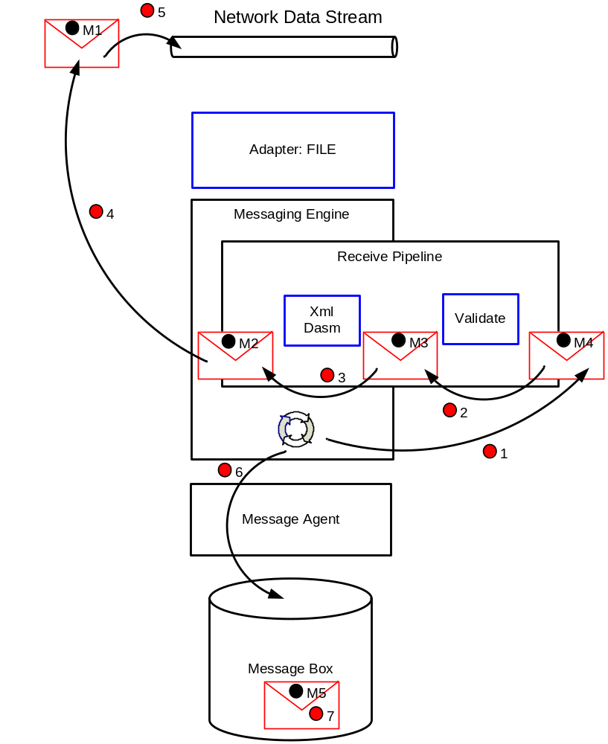

Trouble Shooting Tip: On the send side, since the adapter is responsible for reading the stream, it should be noted that if the transmit adapter wishes to read any message context properties that are promoted or written in the transmit pipeline, these properties may not be written until the stream is read in it entirety since this is the point at which the adapter can be sure that all of the pipeline components have finished executing.

Stream Seekability
In many scenarios the data stream is not seek-able, for example consider an HTTP adapter receiving data using chunked encoding, for the data stream to be made seek-able the adapter would need to cache the data as it is read, either in memory or onto disc, clearly this is not optimal and requires additional resources. Further, many of the out of the box pipeline components operate in a forward only streaming fashion.

There are scenarios when an adapter may need to seek the stream back to the beginning in order to handled failed messages that need to be suspended. For example, an HTTP adapter that is receiving data using chunked encoding in order to submit the response message in a solicit-response pair. For these scenarios the BaseAdapter in the SDK has a useful helper class, called a virtual stream. The idea behind a virtual stream is that the data in the stream is cached in a memory stream until it reaches a threshold, over which the data will be overflowed to a secure location on disc. One the stream is closed the disc file is automatically deleted. This approach allows forward only streams to be made seek-able.

Receive Adapters
Receive Adapters receive data from the ‘wire’ and submit it into BizTalk, this can be a one-way or a two-way message exchange pattern.

One way Submit
For a receive adapter to submit a message into the engine, it first needs to create a new BizTalk message, the code sample in the IBaseMessage section illustrates how this is done. The stream that the Adapter sets as the message body should typically be a forward only stream, meaning that it should not cache the data that it has previously read in memory. Before the Adapter submits the message into the engine, it must write two mandatory message context properties in the system namespace onto the BizTalk message, these include the InboundTransportLocation and the InboundTransportType, this is illustrated in the following code snippet. In addition, the adapter may define its own property schema and write message context properties pertaining to the endpoint over which it received the message. For example, and HTTP adapter may wish to write the HTTP headers to the message context, and a SMTP receiver may want to write the subject of the mail to the message context. This information maybe useful to components down stream such as pipeline components, Orchestration schedules or a transmit Adapters.

Assembly References:
Microsoft.XLANGs.BaseTypes.dll
Microsoft.BizTalk.Pipeline.dll
Microsoft.BizTalk.GlobalPropertySchemas.dll

using Microsoft.BizTalk.Message.Interop;
using Microsoft.XLANGs.BaseTypes;

private static readonly PropertyBase InboundTransportLocationProp =
new BTS.InboundTransportLocation();

private static readonly PropertyBase InboundTransportTypeProp =
new BTS.InboundTransportType();

private void StampMsgCtxProps(
IBaseMessage msg, string uri, string adapterType)
{
msg.Context.Write(
InboundTransportLocationProp.Name.Name,
InboundTransportLocationProperty.Name.Namespace,
uri);

msg.Context.Write(
InboundTransportTypeProp.Name.Name,
InboundTransportTypeProperty.Name.Namespace,
adapterType);
}

Once the messages are prepared they can be submitted into the engine, the code sample in Batch Call Back indicates how a one way receive Adapter would submit a message into the engine.

The following object interaction diagram illustrates the API call’s:
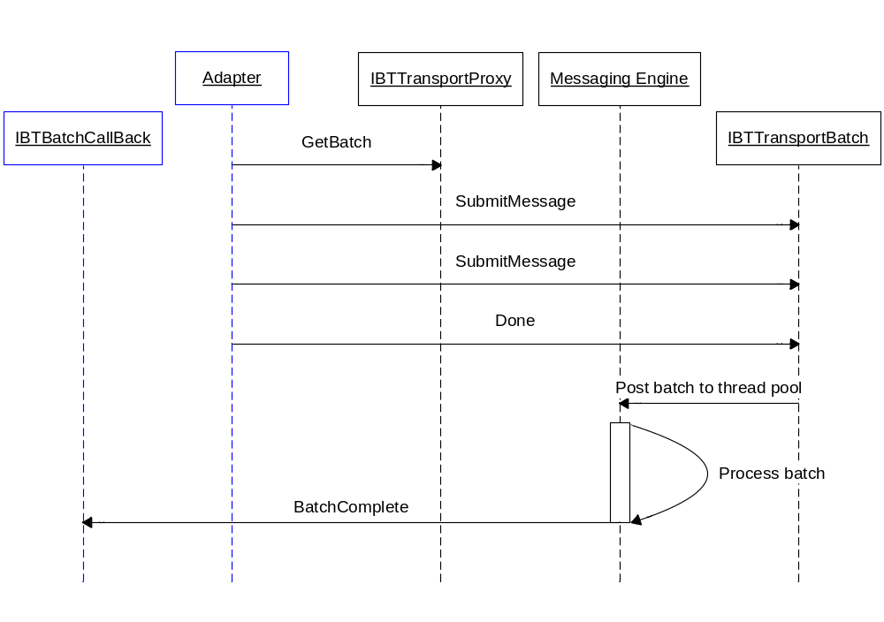

Request-Response
Two way receive adapters may typically be used on one-way or a two-way receive ports, the adapter determines whether the receive location it is servicing is a one-way or two-way port by inspecting the BizTalk configuration property bag as detailed in AddReceiveEndpoint.

The object interaction diagram below illustrates the process of performing a request-response. The Adapter request’s a new batch from it’s Transport Proxy and calls the API SubmitRequestMessage() passing in it’s reference to an IBTTransmitter interface, the engine will deliver the response message on this interface.

It should be noted that because the engine is processing messages asynchronously, it is possible for (a) the BatchComplete() callback to take place before Done() has returned, and (b) the call to TransmitMessage() could be made before BatchComplete() and even Done(). Whilst both of these scenarios are rare, the Adapter should protect itself against this.

It should also be noted that it is recommended that the response message is transmitted using a non-blocking transmission as detailed in the Blocking vs Non-Blocking Transmissions sections.

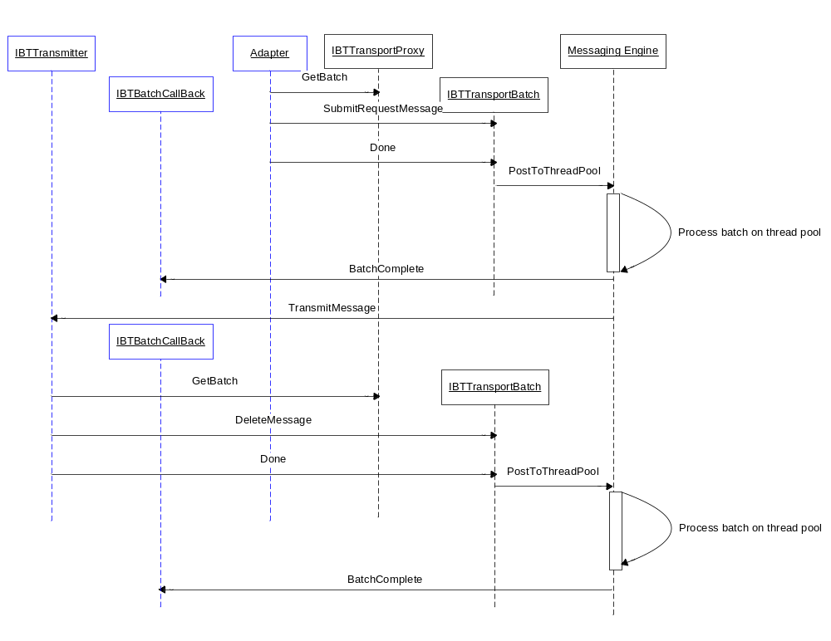

The BaseAdapter in the SDK refresh has a utility class, StandardRequestResponseHandler that encapsulates the request-response semantics as detailed above.

Request-Response Message Timeouts
When an adapter submits a request-request message it needs to specify the timeout of the request message on the IBTTransportBatch.SubmitRequestMessage() API, response messages will only be delivered to the adapter within the timeout, after the timeout expires a Negative Acknowledgment (NACK) will be delivered to the adapter instead of the response message. If the adapter does not specify a timeout value the engine will use the default value of 20 minutes.

The default timeout for request-response messages maybe controlled using the following registry key for receive adapters:

DWORD
HKEY_LOCAL_MACHINE\SYSTEM\CurrentControlSet\Services\BTSSvc{Host Guid}\MessagingReqRespTTL

The registry key is in a different location for Isolated receive adapters:

DWORD
HKEY_LOCAL_MACHINE\SYSTEM\CurrentControlSet\Services\BTSSvc.3.0\MessagingReqRespTTL

NACK’s are SOAP Faults, there are potentially two ways to handle them, typically the adapter will return the NACK back to the client and the client will deal with the NACK, alternatively the transmit pipeline handling the response message may be configured to change the shape of the response message, either using a map or a customer pipeline component.

Transmit Adapters
Transmit Adapters are delivered messages from the engine and transmit the data over the ‘wire’, they may send messages using a one-way or two-way message exchange pattern, called solicit-response adapters. Of course the processing of the message data should always be performed in a streaming fashion.

Blocking vs Non-Blocking Transmissions
The Messaging Engine will deliver messages to the transmit adapter either in IBTTransmitter.TransmitMessage() or IBTTransmitterBatch.TransmitMessage() depending on whether or not the adapter is batch aware or not. Both versions of the method have a boolean return value which indicates whether the adapter sent the message.

If the adapter returns true the engine will delete the message from the application queue on behalf of the adapter, if however the adapter returns false, the adapter is responsible not only for deleting the message from the application queue but also, for handling any transmissions failures that for example require the message to be retried for transmission, suspended etc.

The adapter returning false should be a non-blocking call, the TransmitMessage() implementation should therefore be a light weight call whereby the adapter simply adds the message to an in-memory queue ready to be transmitted. The adapter should have its own thread pool which will service the in-memory queue, transmit the message, and then notify the engine of the outcome of the transmission.

The Messaging Engine’s threads are is typically more CPU bound than the threads used to send data over the wire. Mixing these two types of threads has a negative impact on performance, non-blocking sends enable the decoupling of these two types of thread usage and yield a significant performance improvement.

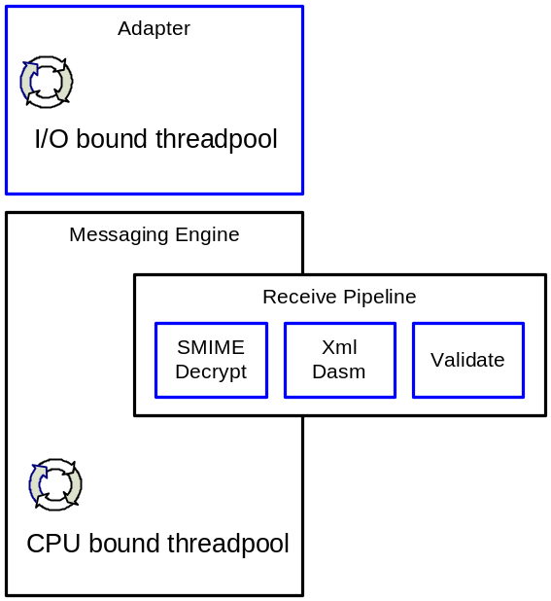

Performance Tip: For the best performance, transmit adapters should be non-blocking and batch aware. When the BizTalk FILE adapter was changed from blocking + non-batch aware to non-blocking + batch aware a three times performance gain was realized.

Trouble Shooting Tip: Blocking transmits can cause a performance degradation of an entire host instance, if the adapter does excessive blocking in TransmitMessage() it will be preventing engine threads from delivering messages to other adapters.

Non-Batched Sends
Adapters that are not batch aware should implement IBTTransmitter as detailed in Transmitter Interfaces section. For each message that the adapter needs to transmit the Messaging Engine will call IBTTransmitter.TransmitMessage(). The object interaction diagram below details the typical approach for transmitting messages, the steps involed are as follows:

- The engine delivers the message to the adapter
- The adapter en-queues the message to an in-memory queue ready to be transmitted
- A thread from the adapters thread pool de-queues the message from the queue, it reads the configuration for the message and transmits the message over the ‘wire’
- The adapter gets a new batch from the engine
- The adapter calls DeleteMessage() on the batch passing in the message that it has just transmitted
- The adapter calls Done() on the batch
- The engine processes the batch and deletes the message from the application queue
- The engine calls back the adapter to notify it of outcome of the DeleteMessage() operation

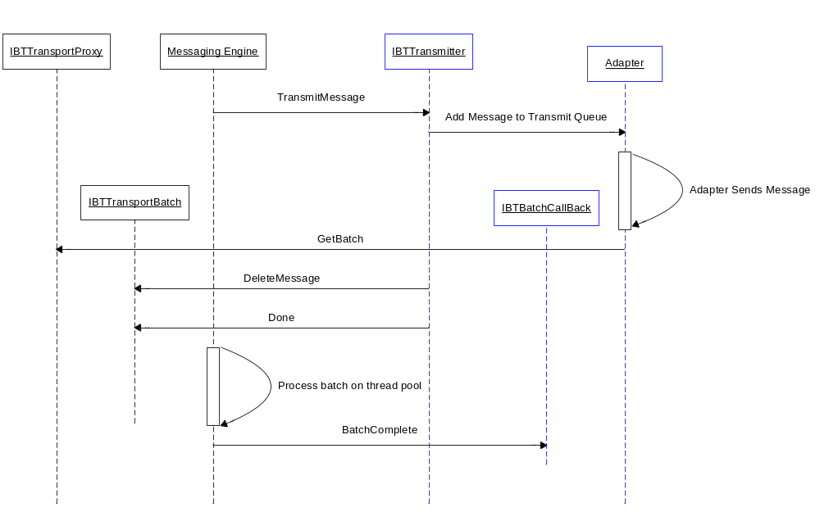

The above object interaction diagram shows the adapter deleting a single message from the application queue; ideally the adapter would batch up operations on the batch as opposed to simply deleting a single message at a time.

Batched Sends
Adapters that are batch aware should implement IBTBatchTransmitter and IBTTransmitterBatch as detailed in Transmitter Interfaces section. When the engine has messages for the adapter to transmit the engine gets a new batch from the adapter by calling IBTBatchTransmitter.GetBatch(), the adapter returns a new batch which implements IBTTransmitterBatch. The engine will then start the batch by calling IBTTransmitterBatch.BeginBatch(), this API has an out parameter which allows the adapter to specify the maximum number of messages that it will accept on the batch. The adapter may optionally return a DTC transaction. The engine will then call IBTTransmitterBatch.TransmitMessage() a number of times which will be greater than zero but less than or equal to the maximum size of the batch as indicated by the adapter. The adapter will then call IBTTransmitterBatch.Done() at which point the adapter should typically en-queue all the messages in the batch to it’s in-memory queue. The adapter will transmit the messages from a thread or threads in its own thread pool as in the case of non-batch aware adapters, after which it will notify the engine of the outcome of the transmission.

The following object interaction diagram illustrates the transmission of two messages by a batched transmit adapter.

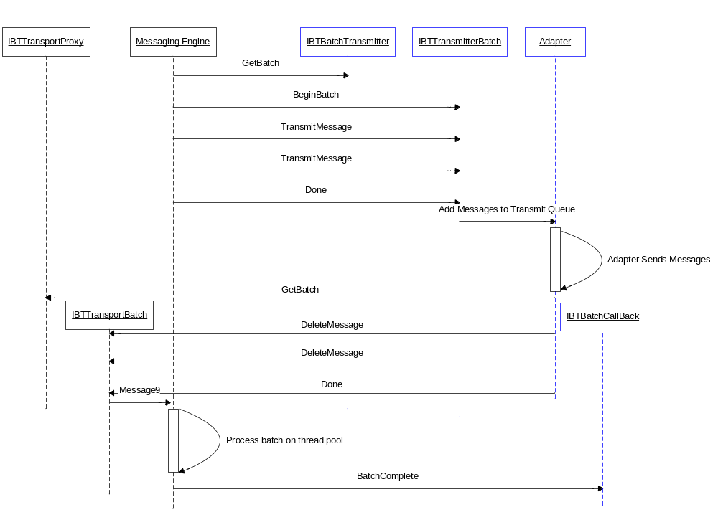

Handling Transmission Failures
The recommended semantics for transmissions failures are illustrated in the diagram below, it should be noted that these are recommendations and not enforced by the engine. An adapter can deviate from these if there are valid reasons for doing so, however care should be taken. Adapters should follow the ‘spirit’ of the recommended transmission failure handling but should not deviate too far from it unless there is good reason.

For example, in general an adapter should not choose never to move messages to the backup transport once all retries have been exhausted, those semantics deviate from the design time configuration. A user may configure a backup transport for a port that would effectively never be used for that transport, therefore misleading the user to the level of transport resilience.

However, more commonly a transport may need to use more retries than is configured, while this is subtlety different it is considered acceptable since the resilience of the transport layer is being increased. In general the API’s exposed by the Messaging Engine are designed to give the adapter the maximum control where possible, with this control comes a greater level of responsibility.

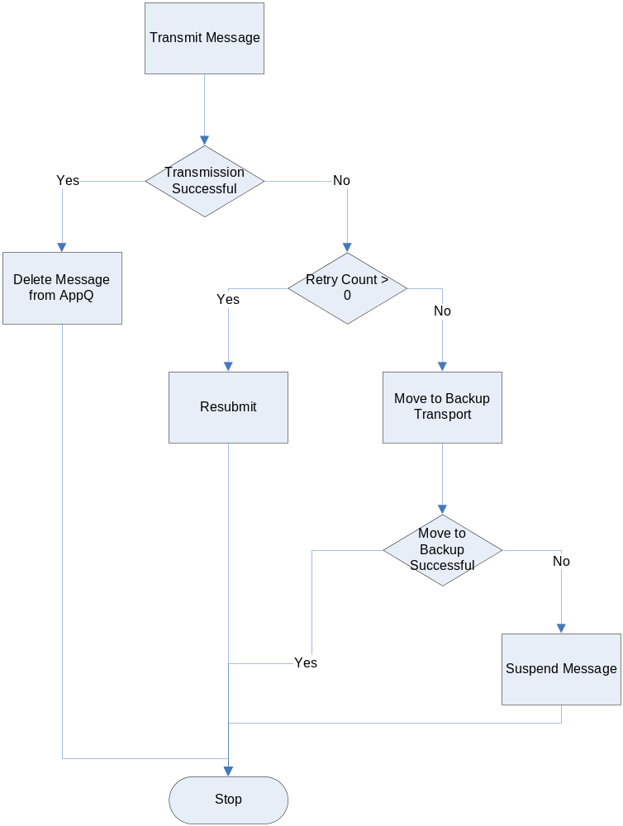

The adapter determines the number of reties available on a message by checking the system context property RetryCount, the adapter calls the Resubmit() API passing in the message to be resubmitted and the time stamp indicating when the engine should deliver the message back to the adapter, value of which should typically be now + RetryInterval. RetryInterval is a system context property the units of which are minutes. Both the RetryCount and RetryInterval in the message context are of course the values that are configured on the send port. It should be noted that in a scale out deployment with instances of the same BizTalk host deployed on multiple machines, when the message is delivered after the retry interval has expired the message may be delivered to the any one of the host instances on any of the machines where they are configured to run. For this reason the adapter should not hold any state associated with a message to be used on the retry since there is no guarantee that instance of the adapter will be responsible for the transmission at a later time.

The adapter should only attempt to move the message to the backup transport after the retry count is less than or equal to zero. An attempt to move the message to the backup transport will fail if there is no backup transport configured for the port, if that fails the message should be suspended.

The following code snippet illustrates how to determine the retry count and interval from the message context, and the subsequent resubmit or move to backup transport.

using Microsoft.XLANGs.BaseTypes;
using Microsoft.BizTalk.Message.Interop;
using Microsoft.BizTalk.TransportProxy.Interop;
…
// RetryCount and RetyInterval are system context properties...
private static readonly PropertyBase RetryCountProperty =
new BTS.RetryCount();
private static readonly PropertyBase RetryIntervalProperty =
new BTS.RetryInterval();

public void HandleRetry(IBaseMessage msg, IBTTransportBatch batch)
{
int retryCount = 0;
int retryInterval = 0;

// Get the RetryCount and RetryInterval off the msg ctx...
GetMessageRetryState(msg, out retryCount, out retryInterval);

// If we have retries available resubmit, else move to
// backup transport...
if ( retryCount > 0 )
batch.Resubmit(
msg, DateTime.Now.AddMinutes(retryInterval));
else
batch.MoveToNextTransport(msg);
}

public void GetMessageRetryState(
IBaseMessage msg,
out int retryCount,
out int retryInterval )
{
retryCount = 0;
retryInterval = 0;

object obj = msg.Context.Read(
RetryCountProperty.Name.Name,
RetryCountProperty.Name.Namespace);

if ( null != obj )
retryCount = (int)obj;

obj = msg.Context.Read(
RetryIntervalProperty.Name.Name,
RetryIntervalProperty.Name.Namespace);

if ( null != obj )
retryInterval = (int)obj;
}

Throwing an Exception from TransmitMessage
If the adapter throws an exception on any of the following API’s IBTTransmitter.TransmitMessage(), IBTTransmitterBatch.TransmitMessage(), IBTTransmitterBatch.Done() the engine will treat the transmission of those messages involved as transmission failures and take the appropriate action for the message (as detailed in Handling Transmission Failures).

For batch aware transmitters, throwing an exception on the TransmitMessage() API will result in the entire batch being cleared and the default transmit failure actions being performed for all messages in that batch.

Solicit-Response
Two way transmit adapters typically support both one way and two way transmissions, the adapter determines whether the message should be transmitted as a one way or two way send by inspecting the IsSolicitResponse system context property in the message context.

The following code snippet demonstrates this:

private bool portIsTwoWay = false;
private static readonly PropertyBase IsSolicitResponseProperty = new BTS.IsSolicitResponse();

...

// Port is one way or two way...
object obj = this.message.Context.Read(
IsSolicitResponseProperty.Name.Name,
IsSolicitResponseProperty.Name.Namespace);

if ( null != obj )
this.portIsTwoWay = (bool)obj;

During a solicit-response transmission the adapter will transmit the solicit message, submit a response to the solicit message and delete the message sent from the application queue. The action of deleting the message from the application queue should be performed in the same Transport Proxy batch as the submission of the response message; this ensures atomicity of the delete and submission of the response. Of course for complete atomicity the adapter should use a DTC transaction whereby the transmission of the solicit message to a transaction aware resource, submission of the response message and the deletion of the solicit message are all in the context of the same DTC transaction. As always, it is of course recommended that the solicit message is transmitted using a non-blocking send.

The following object interaction diagram illustrates the API calls for a solicit-response.

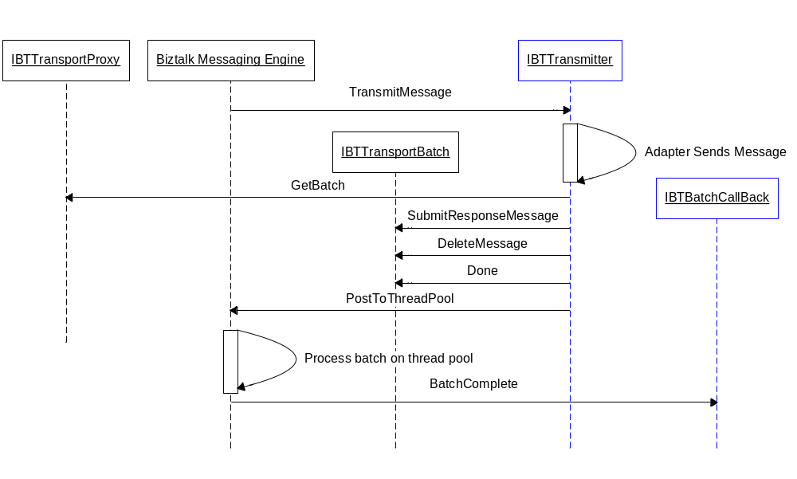

The following code snippet illustrates the main aspects of a two way send. When IBTTransmitter.TransmitMessage() is called by the engine the adapter simply en-queues the message to be transmitted to an in memory queue, the adapter then returns false to indicate that it is performing a non-blocking send. The adapters thread pool services the in memory queue ( WorkerThreadThunk() ), it will de-queue a message and hand it off to a helper method that is responsible for sending the solicit message and receiving the response message, the implementation of which is outside of this text. The response message is submitted into the engine, and the solicit message is deleted from the application queue.

using System.Collections;
using Microsoft.XLANGs.BaseTypes;
using Microsoft.BizTalk.Message.Interop;
using Microsoft.BizTalk.TransportProxy.Interop;
...

static private Queue _transmitQueue = new Queue();
static private IBTTransportProxy _transportProxy = null;

...

// IBTTransmitter...
public bool TransmitMessage(IBaseMessage msg)
{
// Add message to the transmit queue...
lock(_transmitQueue.SyncRoot)
{
_transmitQueue.Enqueue(msg);
}

return false;
}

// Threadpool worker thread...
private void WorkerThreadThunk()
{
try
{
IBaseMessage solicitMsg = null;

lock(_transmitQueue.SyncRoot)
{
solicitMsg =
(IBaseMessage)_transmitQueue.Dequeue();
}

IBaseMessage responseMsg = SendSolicitResponse(
solicitMsg );
Callback cb = new Callback();

IBTTransportBatch batch = _transportProxy.GetBatch(
cb, null);
batch.SubmitResponseMessage( solicitMsg, responseMsg );
batch.DeleteMessage( solicitMsg );
batch.Done(null);
}
catch(Exception)
{
// Handle failure....
}
}

static private IBaseMessage SendSolicitResponse(
IBaseMessage solicitMsg )
{
// Helper method to send solicit message and receive
// reponse message...
IBaseMessage responseMsg = null;
return responseMsg;
}

Dynamic Sends
Dynamic send ports do not have adapter configuration associated with them, they therefore use handler configuration for any ‘default’ properties that the adapter needs in order to transmit messages on a dynamic port. For example, an HTTP adapter may need to use a proxy, the username, password and port could be specified in the handler configuration which the adapter caches at run time.

In order for the engine to determine the transport that a dynamic message is to be sent over, the OutboundTransportLocation will be prefixed with the adapters’ alias. An adapter can register one or more aliases with BizTalk at install time, the engine parses the OutboundTransportLocation at run-time in order to find a match. It is the adapters’ responsibility to handle the OutboundTransportLocation with or with the alias pre pended to it. The following table shows some examples of aliases registered for out of the box BizTalk adapters.

Adapter Alias | Adapter | OutboundTransportLocation example
HTTP:// | HTTP | http://www.foo.com/bar
HTTPS:// | HTTP | https://www.foo.com/bar
mailto: | SMTP | mailto:A.User@MyCompany.com
FILE:// | FILE | FILE://C:\Foo\%MessageID%.xml
DIRECT= | MSMQT | DIRECT=.\MyQueue

Transactions
Adapters may provide a DTC transaction to ensure atomicity between the adapter and the Message Box, this only makes sense if the adapter is reading from and writing to a data source that can be enlisted in a DTC transaction, for example an adapter that writes to SQL Server.

It should be noted that the adapter always owns the transaction, transacted adapters always own the root transaction, and the adapter will always commit or abort the transaction, while the engine will simply vote.

The engine needs to be informed of the outcome of transactions that are supplied by adapters to the engine. When an adapter passes a DTC transaction to the engine, the engine will return an IDTCCommitConfirm interface to the adapter, the adapter needs to call IDTCCommitConfirm.DTCCommitConfirm() passing in the transaction and a boolean to indicate whether the transaction was ultimately committed or aborted.

Transacted Receivers
The main different between transacted receivers from non-transacted receivers is that they use a DTX transaction to ensure atomicity between their data source and the BizTalk Message Box, in general every other aspect of the adapter will be the same.

It should be noted that a request-response receive adapter will only use a transaction for the submission of the request message a different transaction will need to be used for the transmission of the response. This is because the scope of the transaction is in essence between the adapter and the Message Box the request message will not be published until the transaction for the request message is committed.

The object interaction diagram below illustrates the interaction between the adapter and the Messaging Engine. In this example, the following sequence of interactions take place:

- The adapter gets a new batch from the engine
- The adapter creates a new DTC transaction
- The adapter does a destructive read from it’s data source that has been enlisted in the transaction
- The adapter submits the message
- The adapter calls Done on the batch passing in it’s DTC transactions, the engine returns an IBTDTCCommitConfirm interface
- The engine processes the batch and calls the adapter back on it’s BatchComplete implementation
- Since the batch was successful the adapter commits the transactions
- Since the commit of the transaction was successful the adapter calls the IBTDTCCommitConfirm.DTCCommitConfirm() API

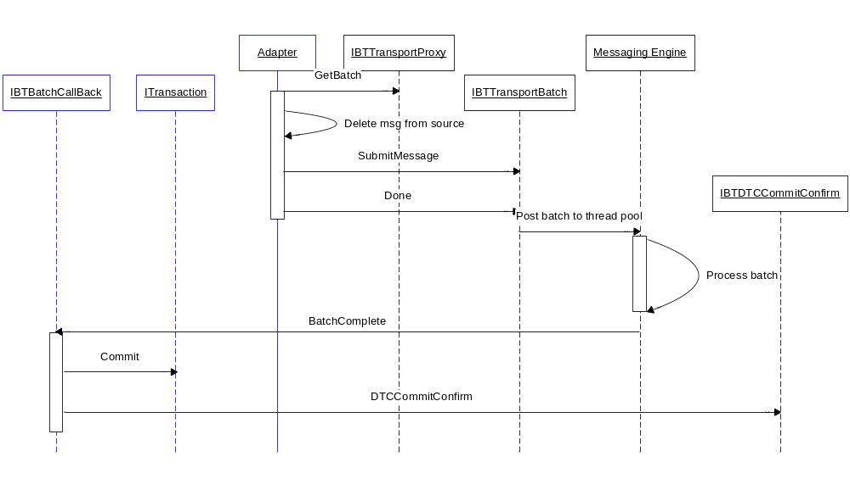

Transacted Transmitters
Again transacted adapters are for the most part very similar to non-transacted adapters, the main difference being that the adapter will send the data in the message to a resource that it has enlisted in a DTC transaction.

Implementation Tip: For transacted sends, the adapter should use the same DTC transaction for the IBTTransportBatch.DeleteMessage() API and for writing the data to the destination, only these two operations need to be transacted. Any other operations such as IBTTransportBatch.Resubmit(), IBTTransportBatch.MoveToNextTransport(), and IBTTransportBatch.MoveToSuspendQ() do not need to be transacted, this is because the engine will use a transaction under the covers and these types of operation do not need to be atomic with respect to the destination.

The following object interaction diagram illustrates the interactions between the adapter and the engine. The sequence of events is as follows:

- The engine gets a new batch from the adapter
- The engine starts the new batch
- The engine delivers two messages to the batch
- The engine calls Done() on the batch, causing the adapter to post the batch to it’s internal transmit queue that is serviced by it’s thread pool
- The adapter creates a new DTC transaction
- The adapter transmits the messages enlisting the destination in the DTC transaction
- The adapter gets a new batch from the engine
- The adapter calls DeleteMessage() for the messages that it has successfully transmitted
- The adapter calls Done() on the batch passing in it’s DTC transaction, the engine returns an IBTDTCCommitConfirm interface
- The engine processes the batch, deleting the messages from the application queue
- The engine calls back the adapter
- The adapter commits the transactions since the batch was successful
- The adapter calls IBTDTCCommitConfirm.DTCCommitConfirm() to inform the transaction was successfully committed

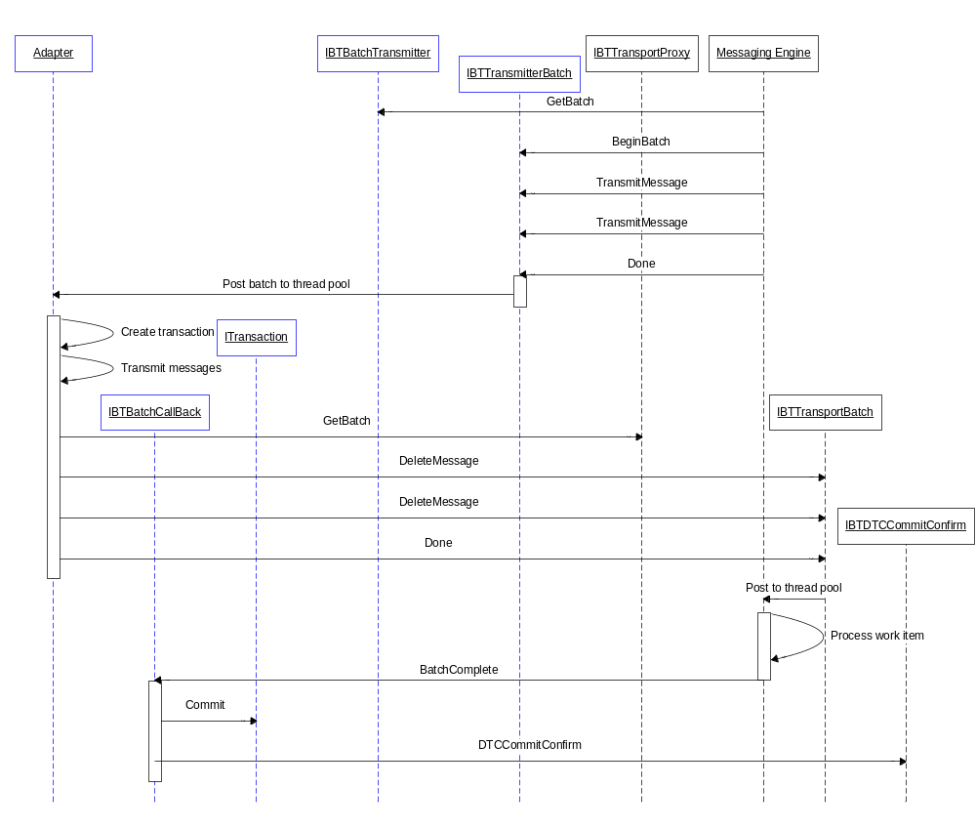

Transacted Solicit-Response Adapters
Unlike two-way receives, two-sends maybe performed using the same DTC transaction. Transacted solicit-response adapters should use the same IBTTransportBatch for the SubmitResponseMessage() and DeleteMessage() operations, this batch should use the same DTC transaction that is used to send and receive the solicit-response message pair, this will ensure atomicity for the solicit-response message exchange.

Service Components and BYOT
As we have seen the engine API’s require a DTC transaction to be supplied, however some.Net components are designed to be used as serviced components and do not allow the transaction to be programmatically committed or aborted, but instead it is automatically committed by the platform.

For these scenarios, the adapter should use Bring Your Own Transaction (BYOT), this allows the adapter to create a DTC transaction, create the .Net component that uses the transaction and allow that component to inherit the created transaction rather than create it’s own transaction. The .Net framework provides System.EnterpriseServices.BYOT for this purpose, however there is a bug than means that BYOT will AV on W2K (up to SP3) if used outside of a COM+ application. The SDK BaseAdapter provides a helper class for this purpose, BYOTTransaction.

Handling Failures

Suspending Messages
In general adapters should suspend messages that they cannot process, for example, receive adapters that experience submit failures should typically suspend these messages, though this does depend on the adapter. However there are security considerations around this, sending bad data to an endpoint whereby the adapter blindly suspends messages that fail submit could render the adapter open to a denial of service attack from a malicious user by filling up the BizTalk suspend queue. Further adapters such as HTTP for example are capable of returning a failure code to the client, indicating that the request has been rejected, for these types of adapters often is does not make sense to suspend the message, but rather return a failure code. Typically transmit adapters will only suspend messages after all of the retries have been exhausted for both primary and secondary transports.

Database Off-Line
The BizTalk service will fail fast in the event of one of the BizTalk databases going off-line, this will cause the service to recycle under these circumstances. The Messaging Engine will make a best effort to shutdown all of the receive locations before recycling the service, if this takes longer than 60 seconds then the service will terminate, since the engine is transacted this will not cause data loss.

This time out can be tuned in the registry using the

DWORD
HKEY_LOCAL_MACHINE\SYSTEM\CurrentControlSet\Services\BTSSvc{Host Guid}\MessagingDBFailoverShutdownTimeLimit

For isolated adapters, since BizTalk does not own the process, the receive locations will be disabled when one of the BizTalk databases go off-line, once the database comes back on-line those receive locations will be re-enabled.

Writing to the Event Log / Tracing
Event log entries may be written by the adapter by using the IBTTransportProxy interface passing in an exception, adapters developed in native code will need to pass in an IErrorInfo interface), IBTTransportProxy.SetErrorInfo( Exception e ).

The Messaging Engine will write to the event log on behalf of the adapter for events such as when an adapter reties a message after transmission failure, when the adapter moves a message to its backup transport or suspends a message. For operations such as these all the adapter needs to do is set the exception on the message prior to calling the API, the follow code snippet demonstrates this:

IBaseMessage msg;
...
// Set exception on msg to indicate why transmission failed...
msg.SetErrorInfo(
new ApplicationException(
"The TCP connection was closed by the destination"));

Security and SSO
Enterprise Single Sign-On (SSO) provides services to store and transmit encrypted user credentials across local and network boundaries, including domain boundaries. Transport adapter writers can leverage SSO API’s to handle the user credentials that transport adapter uses to access back-end applications.
Usually, transport adapters that do not support SSO are required to be configured with a single set of credentials that they will use for accessing backend applications. However for many backend systems single account authentication may not satisfy all its security enforcements. Many applications may provide different access rights depending on the user who is accessing them. SSO allows adapters to dynamically choose the credentials to use for the endpoint based on the user who is trying to access it.

SSO Support for Receive Adapters
Receive adapter that supports SSO performs the following steps after receiving a message and before publishing it to the server:
- Adapter impersonates the sender and obtains the SSO ticket on behalf of sender by using ISSOTicket.IssueTicket API.
- After successfully obtaining SSO ticket adapter stores it on the message context property “SSOTicket” under system namespace (http://schemas.microsoft.com/BizTalk/2003/system-properties)

The following code snippet demonstrates how the ticket is obtained and how it is stored on the message context.

public class MyAdapter : IBTTransport,
IBTTransportConfig,
IBTTransportControl,
IPersistPropertyBag,
IBaseComponent
{
...
private string m_SSOToken = null;

// Get a ticket for the sender
private void GetSSOTicket(IntPtr token)
{
bool impersonated = false;
WindowsImpersonationContext wic = null;

if (token != (IntPtr)0)
{
try
{
// Impersonate the user using his security
// token
WindowsIdentity wi =
new WindowsIdentity(token);
wic = wi.Impersonate();
impersonated = true;

// Get an SSO ticket for the impersonated
// user
ISSOTicket ssoTicket = new ISSOTicket();
m_SSOToken = ssoTicket.IssueTicket(0);
}
finally
{
if (impersonated)
// Revert the impersonation
wic.Undo();
}
}
}
...

private void WriteSSOTicketToContext(
IBaseMessage message )
{
if (m_SSOTicket != null)
{
// Write the SSO ticket to the message context
message.Context.Write(
“SSOTicket”,
http://schemas.microsoft.com/BizTalk/2003/system-properties,
m_SSOToken);
}
}
}

SSO Support for Send Adapters
Send adapter that supports SSO validates and redeems the ticket and obtains the user credentials from the SSO system by using ISSOTicket.ValidateAndRedeemTicket API. The obtained credentials are used by adapter to authenticate with the destination endpoint.

The following code snippet demonstrates how send adapter obtains the user credentials from the SSO system:

public class MyAdapter : IBTTransport,
IBTTransportConfig,
IBTTransportControl,
IPersistPropertyBag,
IBaseComponent
{
...
private string m_UserName = null;
private string m_UserPassword = null;

// Get user credentials from SSO
// AffiliateAppVal is the name of SSO affiliate
// application for the specific destination endpoint
private void GetUserCredentials(
IBaseMessage message,
string AffiliateAppVal )
{
string creds[] = null;
string externalUserName = null;

ISSOTicket ssoTicket = new ISSOTicket();
creds = ssoTicket.ValidateAndRedeemTicket(
message,
AffiliateAppVal,
0,
out externalUserName);

m_UserName = externalUserName;
m_UserPassword = creds[0];
}
...
}

Party Resolution
The Party Resolution pipeline component is responsible for mapping the sender certificate or the sender security identifier (SID) to the corresponding configured BizTalk Server party. Adapters that have this information available to them should set the two system message context properties, WindowsUser and SignatureCertificate to be consumed by the down stream party resolution component if configured.

The WindowsUser property is populated with the domain user of the sender, for example redmond\myBtsUser. The SignatureCertificate is populated with the thumbprint of the client authentication certificate.

Breaking it all Apart and Putting it Back Together – SDK BaseAdapter
By now it is most likely apparent to the reader that the Adapter Framework run-time provides a rich and flexible set of API’s in order to support a wide range of scenarios, with this richness comes a degree of complexity. For this reason the BaseAdapter was developed and shipped in the SDK.

The BaseAdapter consists of a collection of base classes and utility classes, the intension behind which is to provide the boiler plate code on which an adapter can be built, this means the adapter developer may concentrate on the transport aspect of the adapter rather than spend time and resources developing the plumbing code for each adapter they develop. Of course, adapter developers that wish to deviate from the standard behavior may re-implement portions of the BaseAdapter necessary to do achieve their requirements.

At the time of writing this document three sample adapters are available in the BizTalk SDK all of which are based on the BaseAdpater, the table below outlines these adapters, when the were shipped, what they demonstrate and what version of the BaseAdapter they were based on. Additional functionality was added to the BaseAdapter between versions 1.0.0 and 1.0.1, the BaseAdapter is by default built as an independent assembly, the code for it is located at:

$:\Program Files\Microsoft BizTalk Server 2004\SDK\Samples\Adapters\Common\BaseAdapter\v1.0.1

Adapter | Ship Vehicle | Demonstrates | BaseAdapter Version
FILE | RTM | One-way receive / send | 1.0.0
HTTP | SDK Refresh (via Web) | Two-way receive / send  Isolated receive  Virtual stream | 1.0.1
MSMQC | SDK Refresh (via Web) | Transactions | 1.0.1

It is recommended that adapters are built on the BaseAdapter not only to improve productivity, but also to ensure the best practices are followed. Though it should also be noted that this is sample code and as such has not had the same level of testing performed on it as the production code.

Performance Tips
Where possible adapters should be batch aware, this is both with regard to submitting batches of messages, transmitting batches and also generally performing operations on messages in batches. It is recommended that the size of these batches be configurable from the adapters’ design-time.

As mentioned earlier, transmitters should always perform non-blocking sends to avoid degrading the performance of the send host. Further blocking of engine API’s is not recommended in general. Adapters should endeavor to expose performance related behavior via the UI, for example the size of a receive adapters batch to be submitted, perhaps the number of bytes within a given batch.

Writing to and reading from the message context is not a ‘free’ operation in terms of run-time performance, in general adapters should avoid reading, writing and promoting excessive numbers of message context properties. Further, the number of properties that are promoted when submitting messages has a cost associated with it due to the subscription evaluation, an adapter would need to promote a lot of properties to impact the performance, as a good practice it is recommended that only those properties that are required to be promoted are promoted.

For more information regarding performance characteristics, the Performance Characteristics white paper should be referred to.

Throttling In-Bound and Out-Bound
When the load on the BizTalk engine exceeds the configured threshold the engine will throttle adapters and orchestrations in order to ensure optimum performance. On the receive side, when the work load on the engine exceeds a given threshold the adapters call to IBTTransportBatch.Done() will be blocked until the load has decreased sufficiently, thereby stopping the adapter to submit new work into the engine. One the send side, when the engine is throttling adapters sending messages outbound, the engine will simply not deliver new messages to be transmitted until the load on the engine is reduced. For these reasons, the adapter does not need to be concerned with throttling unless it is required for example to limit the number of connections to a backend system, for these types of scenarios, neither the engine nor the Adapter Framework provides any support.

Debugging Tips
Debugging run-time problems often requires a multi faceted approach, requiring data to be gathered from multiple sources such as software tracing, performance counters, the event log entries, WMI events and debugging source code in order to determine the cause of problems or software bugs.

Since receive and send adapters run in the address space of the BizTalk Service the debugger needs to be attached to the BtsNtSvc.exe process in order to debug an adapter. However for isolated receive adapters, the debugger will need to be attached to what ever process it is hosted in, this is of course different depending on the adapter.

The adapter run-time code should be instrumented with tracing code in order to capture run-time diagnostics for trouble shooting. This may be achieved using the Microsoft Enterprise Instrumentation Framework (EIF). Typically it is useful to add trace statements for different levels of severity, for example tracing for error conditions only, tracing for errors and warnings, and finally tracing for errors, warnings and informational statements. Further, more complex adapters may have separate sub-systems which need to be traced in isolation to each other. For example, an adapter may have a network sub-subsystem and a core sub-system, enabling tracing for all sub-systems may generate an excessive amount of ‘noise’ in some scenarios.

Performance counters should be added for the adapter to capture rates and values at run-time to further give a view into the run-time behavior of the adapter, for example an adapter may wish to publish performance counters for the raw numbers of messages sent on a per-endpoint as well as the rate of message sent per second.

WMI events may also be useful for some critical error scenarios, for example, if an adapter hits a critical error which causes it to shutdown a receive location, firing a WMI event would allow an administrator to listen on that even and take some appropriate action.

Adapter Testing
Before shipping a custom adapter for BizTalk Server it should be remembered that an adapter should be developed to enterprise software quality, while it is not the intention to completely detail how adapters should be tested, this section gives a flavor for what needs to be tested. In general the testing of run-time code such as adapters should cover three broad categories, functional testing, stress testing and performance testing.

Function Testing
The adapter should be tested for all permutations of its functionality, this includes both positive tests and negative tests, positive tests should include but not be limited to the following scenarios:

- Receive a message(s)
- Transmit a message(s)
- Transmit a message using a dynamic port
- Disable receive locations
- Update configuration
- Ensure service windows are working for both receive and send adapters
- Ensure transactional integrity for transacted adapters

Negative tests should include but not be limited to:
- Receive a bad message(s)
- Receive a mixed batch of messages, some good and some bad
- Transmit failure:
  - Retry successful
  - Retry fails, move to next transport successful
  - Move to next transport fails, suspend message
- Transmit a mixed batch of messages
- Database fail over

Stress Testing
Adapters are run-time components and as such should meet the stringent requirements for run-time software. Typically stress testing is carried out by running scenarios under load for a period of time, further high stress and low stress mean time between failure test should be performed, whereby the adapter is run under load for a measured time period.

Some rough guide lines for these might be running the adapter at high stress for something in the order of 72 hours; where by the number of messages through the adapter causes the CPU utilization to be in the region of 80 to 90%. For low stress, the CPU utilization would be in the region of 30 to 40% for something in the order of 120 hours.

Performance Testing
Adapters should be developed with performance in mind, this paper has high lighted many areas where performance maybe optimized. Before releasing an adapter its performance should be validated, it is important to ensure its performance scales up and scales out, in other words, adding more CPU’s will lead to a performance increase as will adding more machines. Profiling the code can help to eliminate performance bottlenecks.

Adapter Certification Program
Adapters that are to be commercially marketed and sold should be run through the BizTalk Server 2004 Certification Program, this is an independent validation program that is run by Unisys. The program was developed in conjunction with Microsoft and has a number of targeted tests designed to find deficiencies in adapters.

The program covers the following:

- BizTalk Server Adapter Framework Compliance
- Setup and Configuration
- Reliability Under Stress
- Fault Tolerance
- Security
- Globalization
- Diagnostics

More information can be found regarding the certification program by emailing mailto:biztalkcertification@unisys.com or visiting the web site http://www.unisys.com/about__unisys/partners/alphabetical__listing/microsoft/microsoft__programs/jupiter1/certification.htm

-----------------------------------------
The information contained in this document represents the current view of Microsoft Corporation on the issues discussed as of the date of publication. Because Microsoft must respond to changing market conditions, it should not be interpreted to be a commitment on the part of Microsoft, and Microsoft cannot guarantee the accuracy of any information presented after the date of publication.

This White Paper is for informational purposes only. MICROSOFT MAKES NO WARRANTIES, EXPRESS OR IMPLIED, AS TO THE INFORMATION IN THIS DOCUMENT.

Complying with all applicable copyright laws is the responsibility of the user. Without limiting the rights under copyright, no part of this document may be reproduced, stored in or introduced into a retrieval system, or transmitted in any form or by any means (electronic, mechanical, photocopying, recording, or otherwise), or for any purpose, without the express written permission of Microsoft Corporation.

Microsoft may have patents, patent applications, trademarks, copyrights, or other intellectual property rights covering subject matter in this document. Except as expressly provided in any written license agreement from Microsoft, the furnishing of this document does not give you any license to these patents, trademarks, copyrights, or other intellectual property.

© 2004 Microsoft Corporation. All rights reserved.

